

Department of Computing

Algorithms and Data Structures
(55-508810-AF-202425)

Name: Nabeelah A. Okanlawon
Student ID: 33030385
Table of Contents

1. Project 1 2
1.1 Computational Complexity 2
1.2 Observation of rate of growth 3
1.3 Incorporation of formative feedback 6
2. Project 2 7
2.1 Algorithms in an Algorithmic Language, such as ADL 7
2.2 Data Structures 8
2.3 Software and its Presentation, including testing (and video link) 10
2.4 Descriptive Report, including artefacts 12
2.4.1 Transitioning algorithms to implementation 12
2.4.2 Problem-solving strategy 14
2.5 Incorporation of formative feedback 17
3. Project 3 17
3.1 Data Structure selection 17
3.2Developed Algorithms 18
3.2.1 Algorithm1: Influencers in Unweighted Network 18
Time Complexity of Algorithm1: Discuss about the time complexity of Algorithm1 that you have developed. 18
3.2.2Algorithm2: Influencers in Weighted Network 19
Time Complexity of Algorithm2: Discuss about the time complexity of Algorithm2 that you have developed. 19
3.3 Implementation 21
3.3.1 Implementation details 21
3.3.2 Publishing your project 22
3.3.3 Evaluation 22
3.4 Reflection 23
3.4.1 Video 23
3.4.2Feedback 23
4. Project 4 23
4.1 Introduction to Bin Packing Problem 24
4.2 Random Mutation Hill Climbing 24
4.3 Algorithm Design 25
4.3.1 Solution Representation 25
4.3.2 Fitness Function Analysis 25
4.3.2 Small Change Strategy 28
4.3.4 Data Structure 30
4.3.5 Algorithm Pseudocode 31
4.3.6 Experiment Strategy 31
4.4 Results 32
4.5 Testing 32
4.6 Software and its Presentation, including testing (and video link) 33
4.7 Incorporation of formative feedback 33
5.0 Bibliography 33

1. Project 1

Computational Complexity
Justification for the complexity of the given algorithm
for i ← 1 to n by 1 do //do (n-1) times
for j ← 1 to i by 1 do //do (n-1) times
for k ← 1 to j by 1 do //do (n-1) times
print (“What a great challenge!”) //do n times
end
end
end

Outer loop (i)
Runs from I = 1 to I = n so it iterates n times.
Middle loop (j)
For each iteration of the outer loop, the middle loop runs from j = 1 to j = I, for each value of I, the number of iterations in the loop will be I.
Inner loop (k)
For each iteration of the middle loop, the inner loop runs from k = 1 to k = j, the number of iterations in the inner loop will be equal to j for each value of j
Hence, this can be written mathematically as:
$$\sum_{i=1}^{n}{\sum_{j=1}^{i}{\sum_{k=1}^{j}{1}}}$$
The innermost loop is simplified to:
$$\sum_{k=1}^{j}{1=j}$$
The middle loop is then simplified:
$$\sum_{j=1}^{i}{j}=1+2+3+…+i= \frac{i (i+1)}{2}$$
This is derived from the previously known constant for the sum of integers.
The inner loop can finally be solved as:
$$\sum_{i=1}^{n}{\frac{i(i+1)}{2}}$$

$$= \frac{1}{2} \sum_{i=1}^{n}{i^{2}}+\frac{1}{2}\sum_{i+1}^{n}{i}$$
The sum of squares = $\frac{n(n+1)(2n+1)}{6}$

The sum of integers =$\frac{n(n+1)}{2}$

The complexity can then be simplified as: $\frac{1}{2}\left(\frac{n\left(n+1\right)\left(2n+1\right)}{6}\right)+\frac{1}{2}(\frac{n(n+1)}{2})$

$$=\frac{n\left(n+1\right)\left(2n+1\right)}{12}+\frac{n\left(n+1\right)}{4}$$
Removing noise (constants that do not significantly affect the complexity) results in:
$$\frac{n^{3}}{6}+\frac{n^{2}}{4}$$
Since the complexity is defined by the highest order, this results in $n^{3}$ and a complexity of O ($n^{3}$ ).

1.2 Observation of rate of growth
Comparison of complexities n^2 and (2^n)/4

n | n² | (2^{n})/4
1 | 1 | 0.5
2 | 4 | 1
5 | 25 | 8
8 | 64 | 64
10 | 100 | 256
20 | 400 | 262144
50 | 2500 | 281474977500000
100 | 10000 | 3.16912650E29

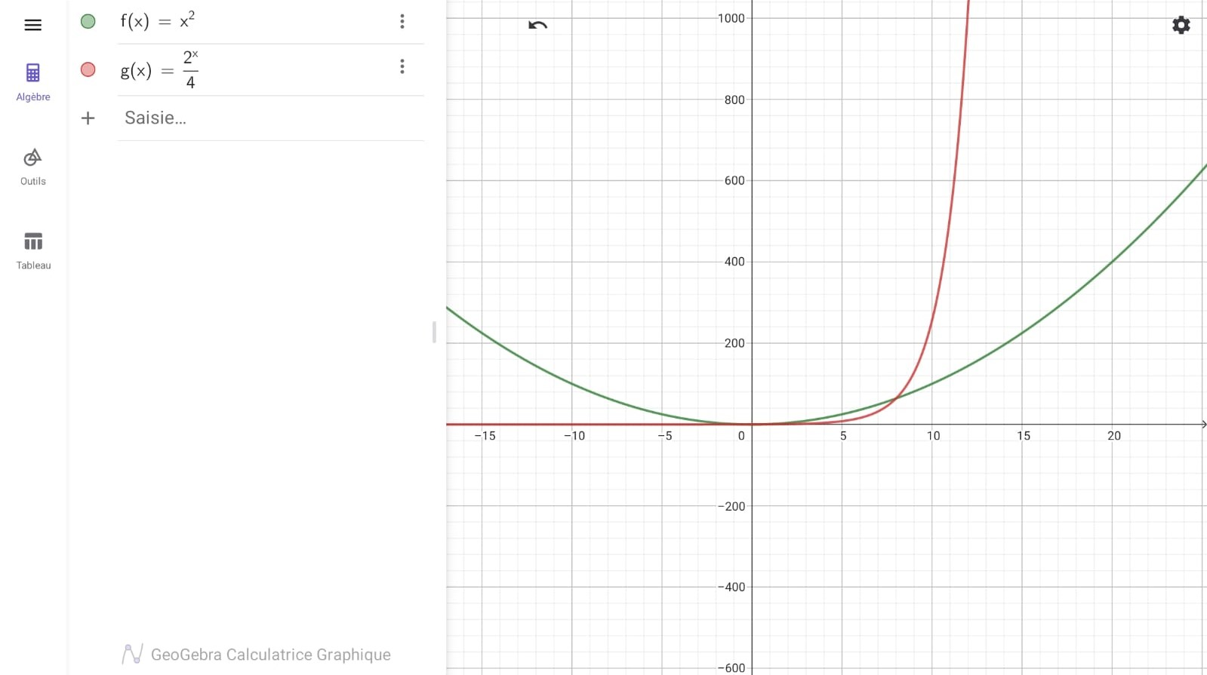

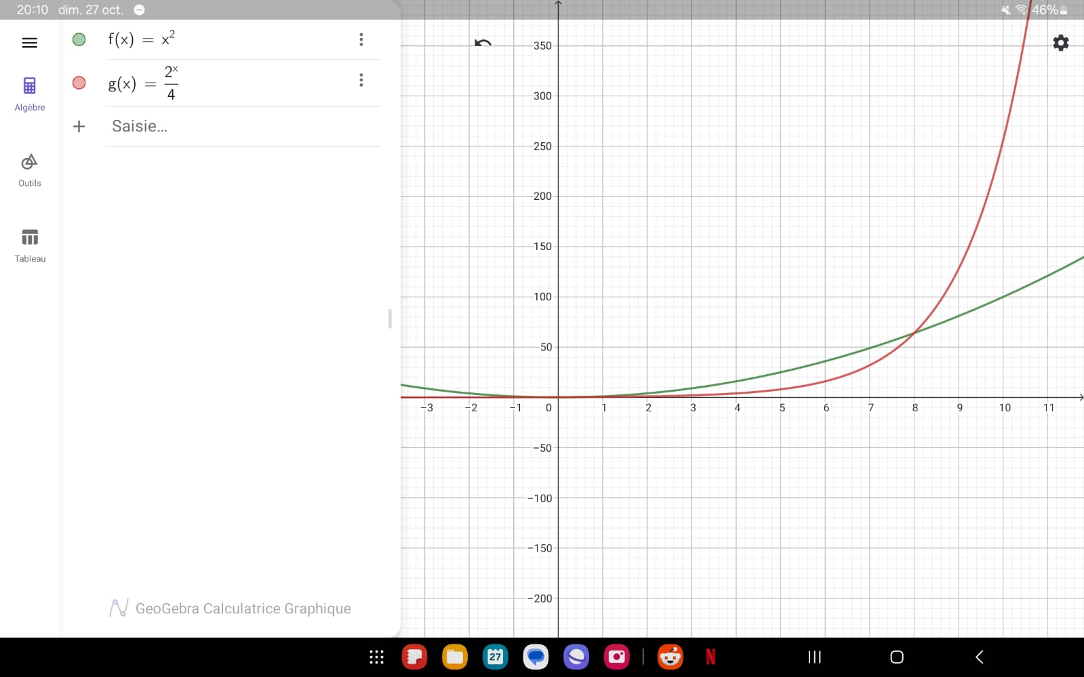

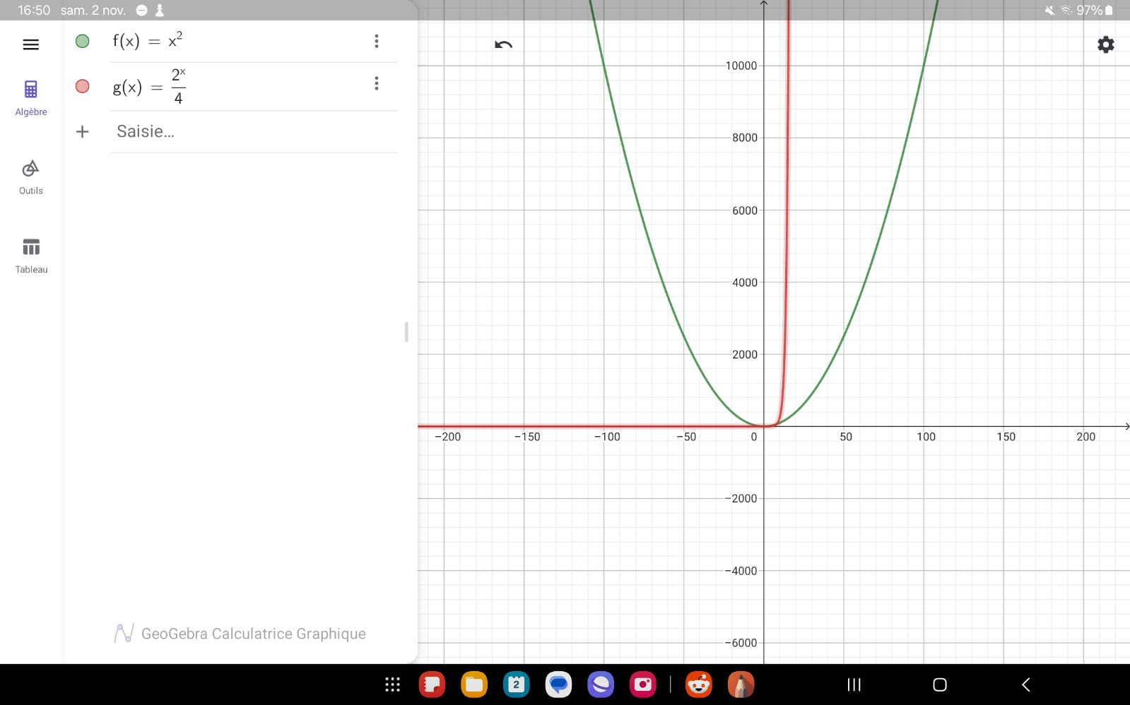

Analysis: Through comparison of the graphs and tabular view of data points, the (2^n)/4 function is significantly less optimal than the n^2 function. This is clear in the rapid growth difference between the two functions on the graphs, making n^2 the obvious choice for larger data inputs. However, this only holds true for large data inputs, where exponential growth is infeasible.
Growth rate and Practicality
For small inputs (below 10 inputs), the complexity (2^n)/4has a manageable growth rate. This allows it to be effective for small scale recursive problems (or a basic brute force algorithms) where a full solution space needs to be explored. This includes small puzzles, basic search problems, or combinatorial tasks.
After 8 inputs, its (complexity 2^n/4) growth rate rather sharply expands. Exponential growth like this is rather unmanageable after 20 inputs on most computer hardware, because of the exponential growth of time taken to compute. A common application of exponential complexity is in solving combinatorial problems in cryptography where exploring a large option of possibilities is vital. Due to the inefficiency of exponential functions, optimized solutions like dynamic programming or heuristics are preferred to reduce time and space cost.
In the case of the function n^2, quadratic complexity is often useful in simple sorting algorithms like bubble and insertion sort because of its reasonable performance at up to several thousand inputs. It is a good choice for non-critical large datasets where occasional time delay or slowness is not a very impactful.
After the intersection at 8 inputs (where the execution time for both complexities is equal), the quadratic function remains stable and in fact usable across a vast range of input sizes. Such growth rate is ideal for algorithms that handle medium to large data inputs.
Space Efficiency
Generally, algorithms with quadratic growth rate do not impose heavy memory demands, as space requirement often depends on details in implementation like array or matrix usage. This quality makes quadratic algorithms more efficient in terms of memory, especially in cases where time and space efficiency need to be balanced and considered equally.
For exponential algorithms, mostly recursive are associated with high memory usage due to recursively calling the memory stack, which can result in stack overflow for medium to large inputs.
When implementing recursion, each function call consumes stack space which grows exponentially as the input size increases. While memoisation can help reduce this by storing previously computed results, there is an additional space complexity with the stored results. By avoiding redundant calculations, memoisation reduces the time cost but it also consumes memory, making it also unsuitable for the case where space and time efficiency is essential.
Conclusion: overall, the O(n^2) complexity is preferable for a wider range of applications because it balances time and space efficiency, it is also scalable for larger input sizes. On the other hand, the O((2^n)/4 complexity is suited best for problems that require and are guaranteed smaller input sizes because of how unsustainable it becomes with medium to large input sizes.

1.3 Incorporation of formative feedback

Date and Time | Name of the Tutor | Feedback of the tutor | How the comment is addressed
2nd October  11.00 - 13.00 | Mehmet Ozcan | Part 1: Reconsider solution as a harmonic progression/growth of the function | I ran the algorithm in C# code and intuitively deduced the solution as an arithmetic progression
16th October 11.00 - 13.00 | Mehmet Ozcan | Part 1: good  Part 2: There is no requirement to write an algorithm for this project.  Do not ignore noise in the given complexity | Part 1: no further changes needed to be made  Part 2: Removed my test and analysis using Fibonacci algorithms and used the complexity functions as is, making sure to include the noise (4 in (2^n)/4)  Used recommended graphing tool (GeoGebra)

2. Project 2

2.1 Algorithms in an Algorithmic Language, such as ADL
In the 2nd project I was tasked with creating an algorithm based on 1940 psychological experiment conducted by Robert Tyson holding the notion that the intelligence of rats was determined more by environmental rather than genetic factors (Gray, 2011). The task involved writing an algorithm and subsequently converting into executable C# code that would output a series of possible paths a rat could take when placed in a maze surrounded by walls with only one entry and one exit. Once the rat enters the maze it cannot leave via the entry but only the exit. The maze is denoted with a two-dimensional grid of integers 1 and 0 where 1 represents the walls and 0 represents a traversable path (cell).

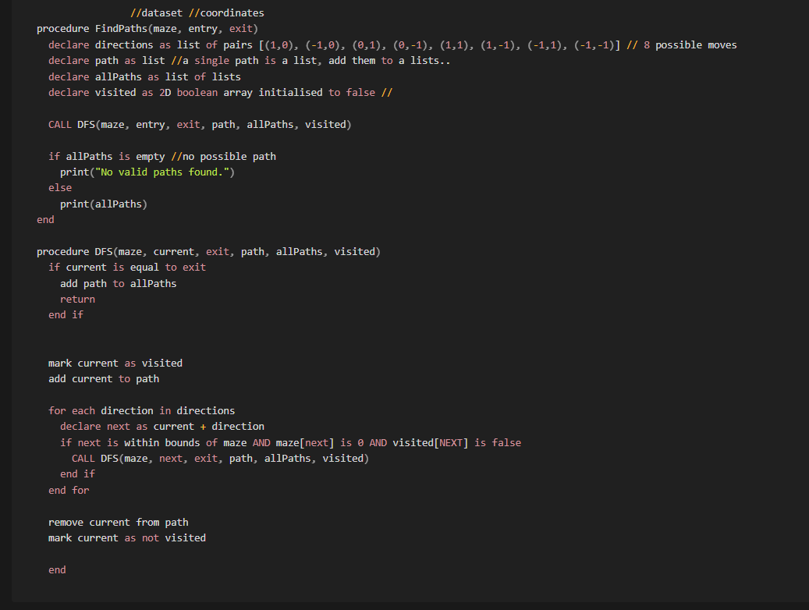
As seen in the ADL pseudocode above, to solve this problem I decided to use a depth first search strategy because of its use of recursion to explore paths. The algorithm begins with declaring necessary data structures to hold the needed data throughout the code execution. Then follows the depth-first search procedure which involves traversing from entry to exit and ensuring that each time the coordinate in the path is not already visited, is a valid traversable cell, and the overall path is unique from all previously found paths.

2.2 Data Structures
Matrix (2D array): This is used to represent the maze structure, with 1 denoting the walls and 0 for the open path. A valid maze (matrix) muse be surrounded by 1’s except in two spots, the entry and exit.
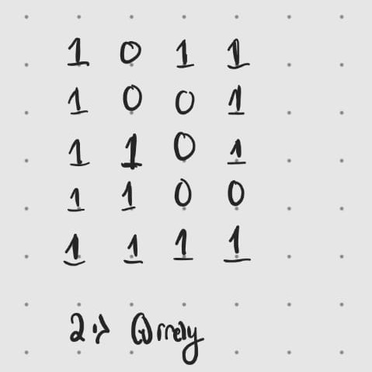
In terms of space time trade-off, the 2D array offers direct access to each cell at O(1) time, making it efficient for lookups and pathfinding. However, in the case of larger mazes (such as in the 1’st provided maze for this problem) the fixed size can lead to higher memory usage in comparison to more dynamic structures (such as a linked list). I still decided to choose a 2D matrix for this problem because of the importance of speed efficiency in pathfinding. It is a better trade off as the fixed structure of the matrix as well ensures reliable and fast operations.
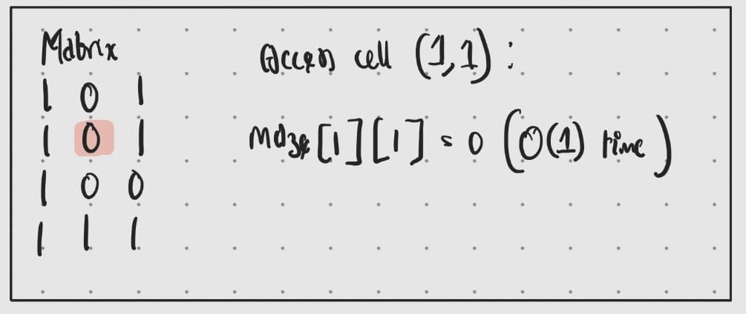

Boolean 2D array (visited array): This is used to track the cells that have been visited during the search to avoid infinite loops (prevent revisiting during DFS function call). It is initialised as false for all cells and can easily be changed to true when a cell is visited.
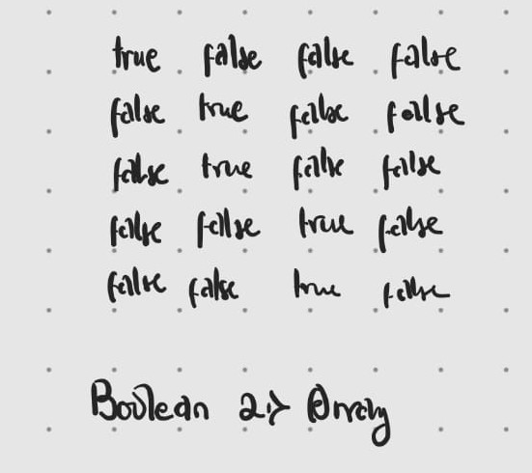

This data structure also has an access time complexity of O(1) time which is helpful for quick lookups. It uses the same amount of memory as the maze because it is a copy in the sense that each cell in this array is directly related to a cell in the matrix. As such it has the same benefits and disadvantages, specifically for larger mazes, it doubles memory usage because it replicates the matrix size. Potentially, a stack (with time complexity of O(log n) could be used to replace the boolean array by storing only visited nodes, but this would increase the recursion depth and could potentially lead to stack overflow for large mazes.

List of Pairs (possible directions): This was used to define the possible directions of movement a rat could take in the maze (east, west, north, south, and diagonals). It provides a compact and efficient way to iterate through possible moves and simplifies calculating the new position during DFS. The idea is to iterate through each of these direction pairs; adding the direction position to the current position of the rat, and then checking that the resulting position is valid, if so, it is added to the path list, and if not, it is marked as visited. This pair list is immensely beneficial, with minimal space usage due to its constant size (of 8 elements) as such the complexity of iterating through this list is also O(1) time per direction.

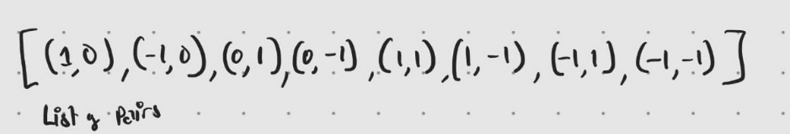

List of Lists (unique paths): This was used to store all the unique paths found, each as a list of coordinates in sequence. In this data structure, each path dynamically creates as a new list and stored next in this list of lists.

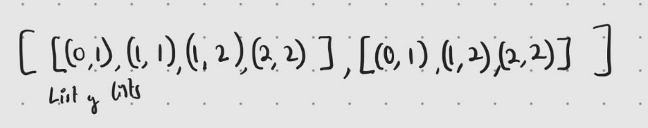

The list of lists dynamically grows to accommodate new paths, which is great in avoiding upfront memory allocation (and potentially memory wastage), however for mazes with many paths, its (the list of list’s) memory usage scales with the number of paths and their respective lengths. Subsequently, this results in a complexity of O(n) to add a path to this list where ‘n’ refers to the length of the path.

2.3 Software and its Presentation, including testing (and video link)
Functionality: The software implements a recursive DFS algorithm to find all unique paths from the entry to the exit in a maze, identify the shortest path, and output all paths and shortest path for analysis.

Testing: In regards with testing, I used multiple test cases with varying maze sizes and configurations to verify correctness. Some of which included:
- A maze with one direct path.
- A maze with multiple paths, including diagonal movement.
- Edge cases such as a fully blocked maze or no valid exit.

The video link demonstrating the testing process is available here: YouTube Link

Acceptance tests

Test 1: Maze with one valid path.
Expected result: One path found.
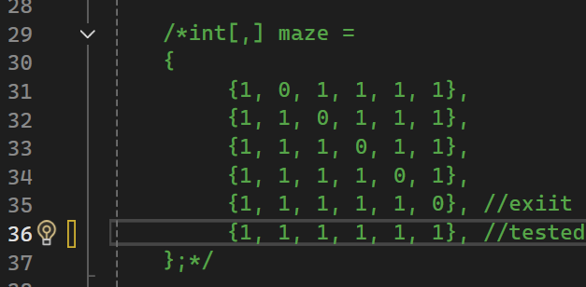
Result:
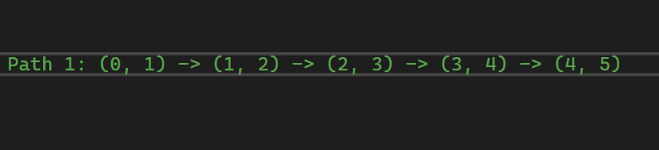

Test 2: Maze with multiple paths, including diagonals.
Expected result: correct count of unique paths.
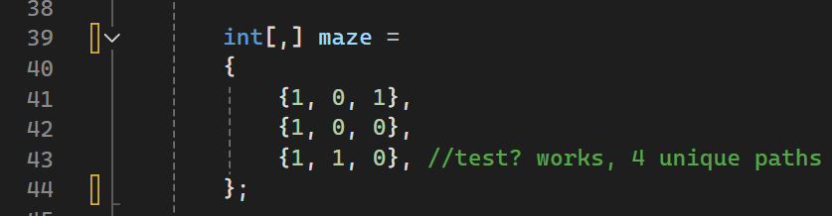
Result:
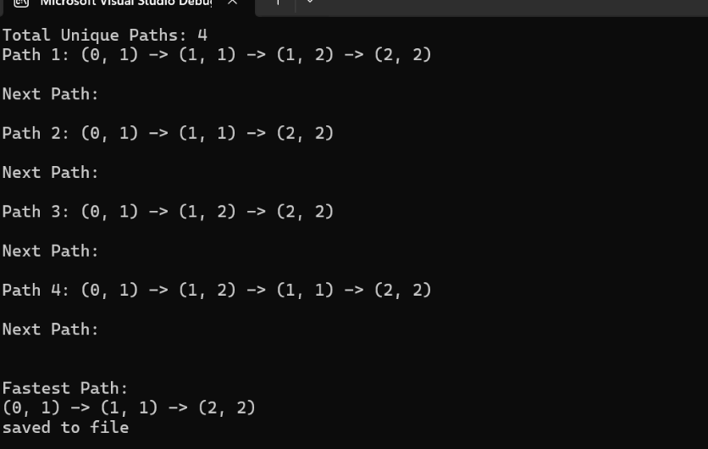

Test 3: Fully blocked maze.
Expected result: Error message stating, “No paths found”.
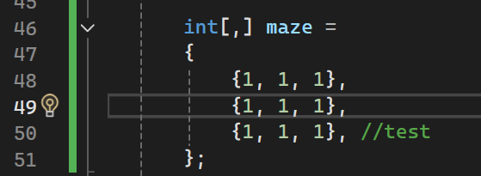
Result:
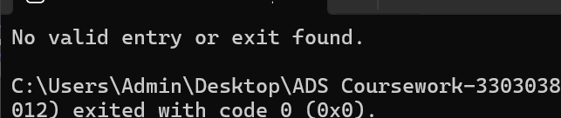
I have included more test mazes in my code to ensure robustness of the code, including the mazes given with this problem.

2.4 Descriptive Report, including artefacts

2.4.1 Transitioning algorithms to implementation

The transition from ADL pseudocode to C# involved breaking the problem into modular, executable components while ensuring the recursive nature of the algorithm remained intact. Below, I outline the key steps in this transition, referencing my pseudocode and explaining the decisions I made during implementation.
Conversion to C#: The recursive DFS logic was directly translated to a DFS function in C#. Some key decisions i made include:

Use of Tuples: Instead of manually breaking coordinates into separate variables, tuples like (int, int) were used to represent the positions, simplifying function parameters and improving readability.

Direction Handling: The list of possible directions was represented as a static array of offsets (an integer indicating the distance or displacement between the beginning of the object (2d matrix in this case) and a given element or point i.e. the new position (Kernighan & Ritchie, 2017)) named “row Dir” and “col Dir”, and when needed where iterated in a loop to calculate the new positions (by addition).

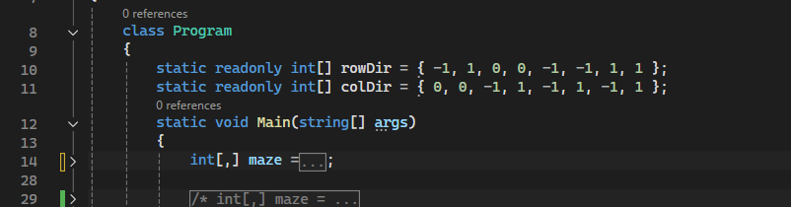
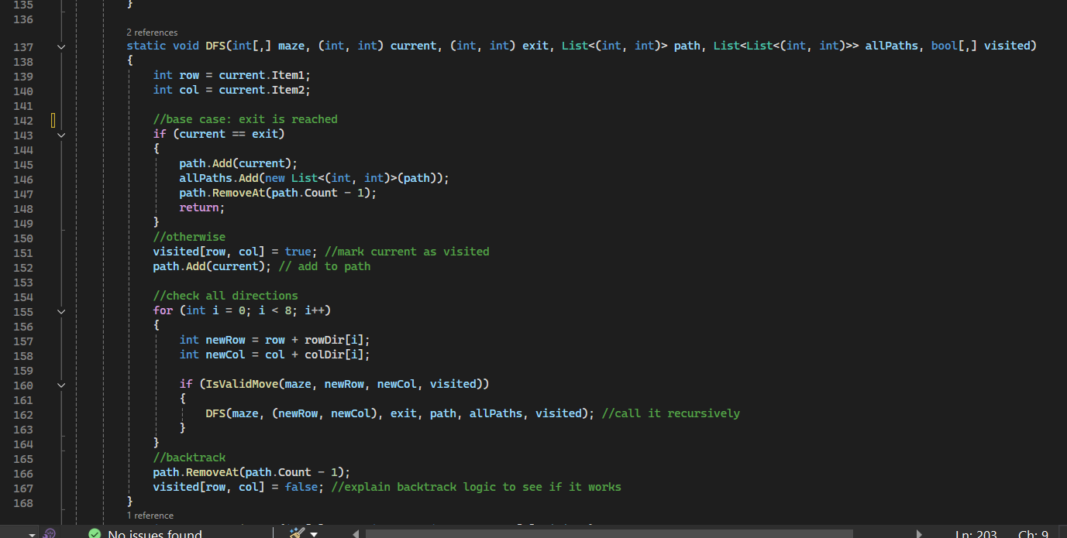
Initially, I considered iterative DFS using a stack, which avoids recursion depth limits (the limit to the number of times the deepest part of a procedure is called (Cornelius & Kirby, 1975)). However, recursion is natural for problems like DFS and improves code readability and so felt like a proper route to take.

In deciding to focus on modularity and code readability, I made sure to identify when I repeated code and converting it to a helper function instead. Here are the few helper functions used in the code and how the pseudocode influenced their design:

IsValidMove: The pseudocode includes a condition to check whether a move is within bounds and when translating to C# code I achieved this via a boolean function that iterates through the list of direction pairs to check whether a move to a new position is valid based on boundaries (is it out of bounds of the maze), wall checks (is the new position leading to a wall), or visited status (if it is a traversable path, is it already marked as visited). It returns either true or false accordingly.

FindEntry and FindExit: The pseudocode assumes the entry and exit are given, but I decided in the interest of robust code building to dynamically find them when presented with a maze. Both these direction pair functions are used to dynamically identify the first and last open cells in the maze, to avoid hardcoding the coordinates and potential human error that comes with this. It is also especially useful when there are multiple mazes to test and quickly identifies if a maze has a valid entry and exit point without need of calling the DFS function.

OutputPaths: This was called at the end of the DFS function to allow output to be displayed on the console. Rather than having the code displayed chaotically in ‘Main’ a single output function is called to enhance code readability.

WritePathsToFile: Aside from displaying the possible maze paths on the console, I intuitively added this optional function that writes the output to a file for further storage and manipulation. Regarding the experiment the maze path data could be needed for study and implicitly saving it to a file takes advantage of the ability to automate file creation. I considered including a visualisation method that used symbols like S and E for the start and end respectively and ‘*’ or ‘-’ to specify the path being traversed for a visual representation of a path but decided against it as it was not necessary for the solution.

FindShortestPath: This function was used to derive the shortest path amongst all found paths. Ultimately the goal of this algorithm is to be able to find the shortest path a rat could take (to gain the most treats) so specifying this was important. It is in the “outputpath” function after all the paths have been displayed.

While the initial design (not shown in the pseudocode) included a Hash Set (a data structure that stores unique elements in a hash table and allows for fast look up, addition and removal of elements) to ensure path uniqueness, I deemed it unnecessary due to the inherent nature of the DFS algorithm. The algorithm has a backtracking mechanism that ensures revisited cells are unmarked and excluded from duplicate paths. Also, diagonal movement introduced variability in traversal, ensuring that the paths with different movement sequences remain distinct even if they reach the same exit. Thus, by omitting the Hash Set, this solution avoids the overhead of storing and checking large strings (or canonical representation of paths), thereby reducing memory usage whilst ensuring that functionality is not compromised. Despite the absence of a Hash set, the algorithm effectively tracks paths and sue to the robustness of the visited logic, duplicate paths do not arise during the exploration. This solution exemplifies how careful algorithm design can achieve efficiency without need for additional data structures.

2.4.2 Problem-solving strategy

The strategy for solving the maze pathfinding problem relied on recursion, a process where a function implicitly calls itself. This was the depth first search function which also handles backtracking. This approach was also supported with efficient and well-chosen data structures.

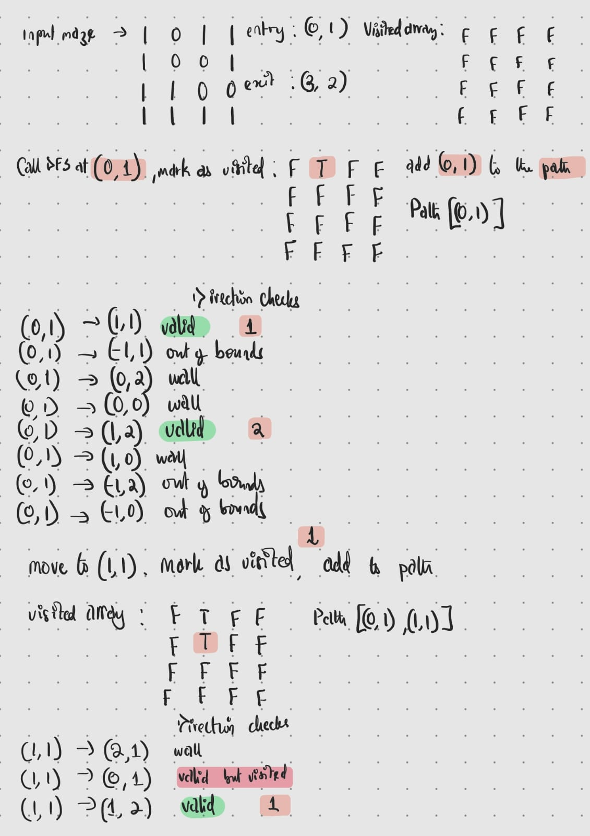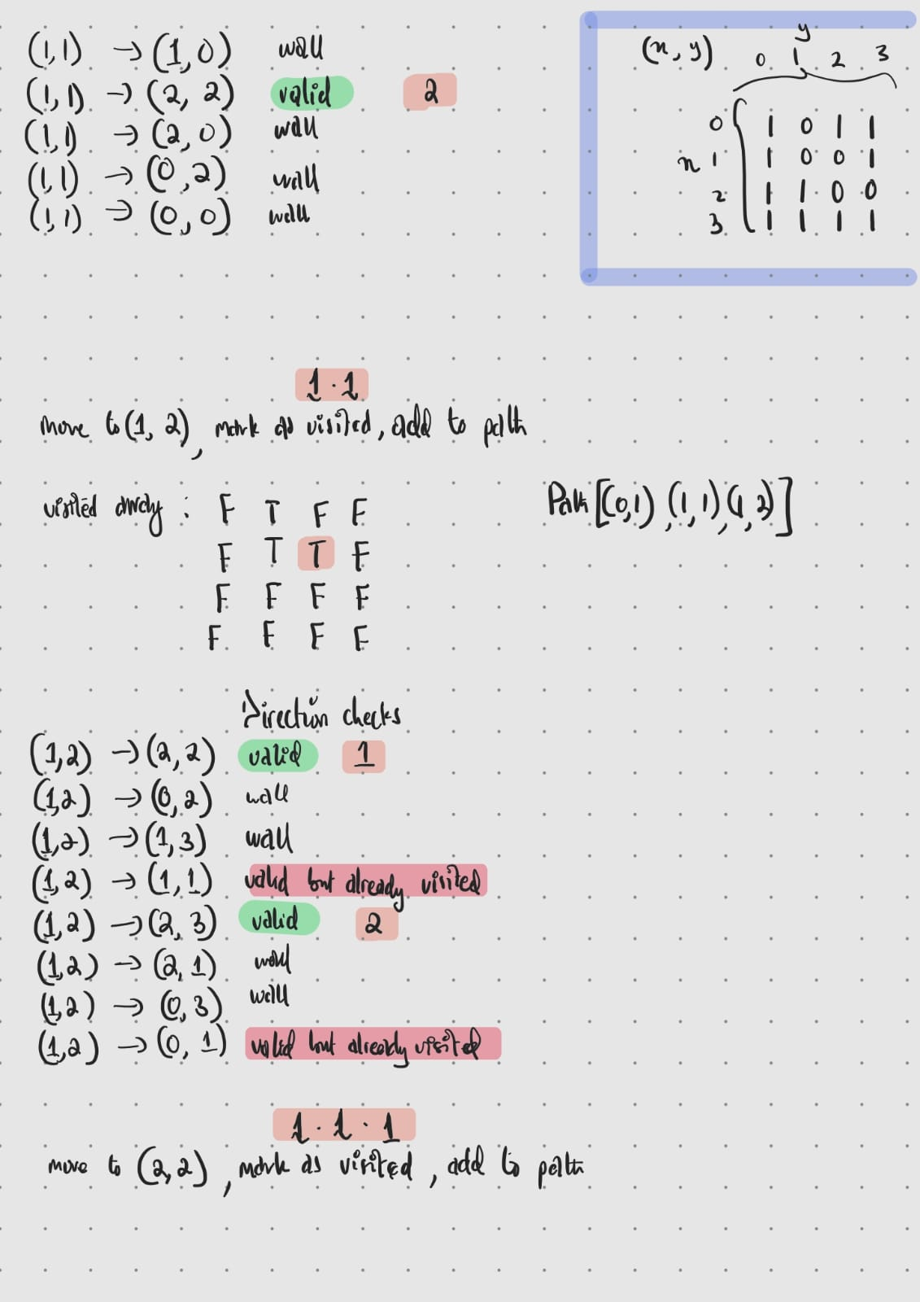

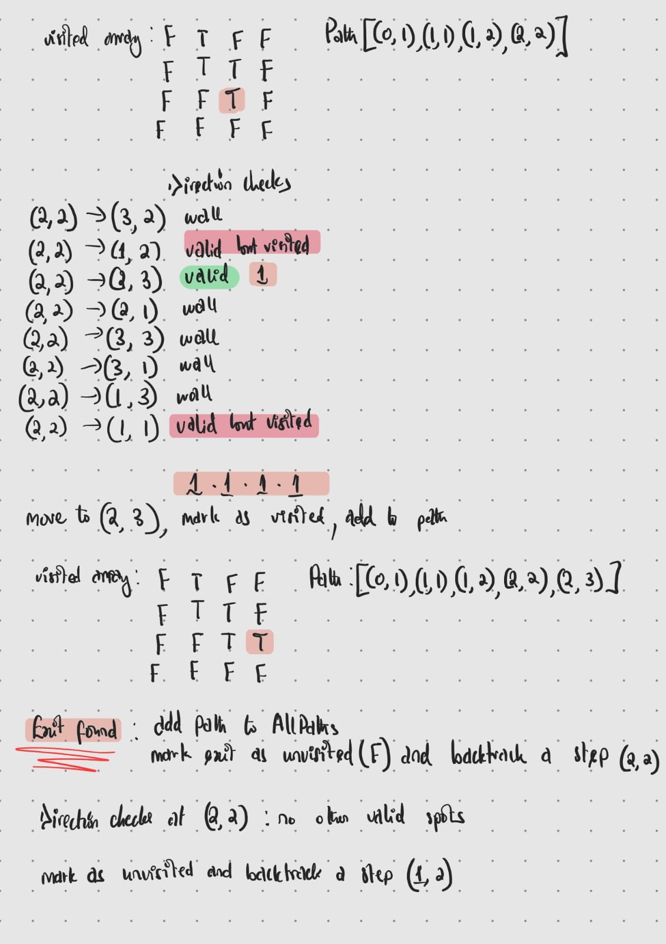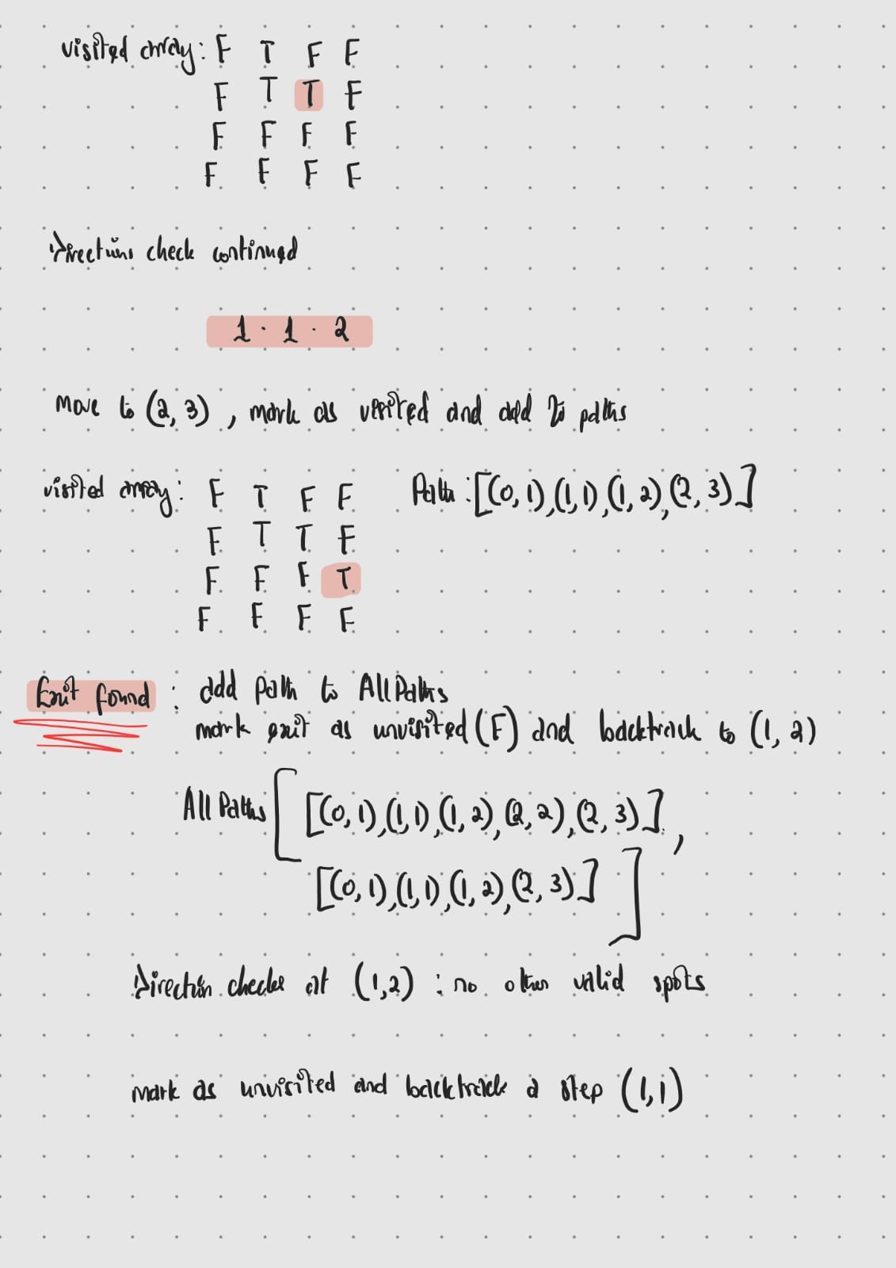

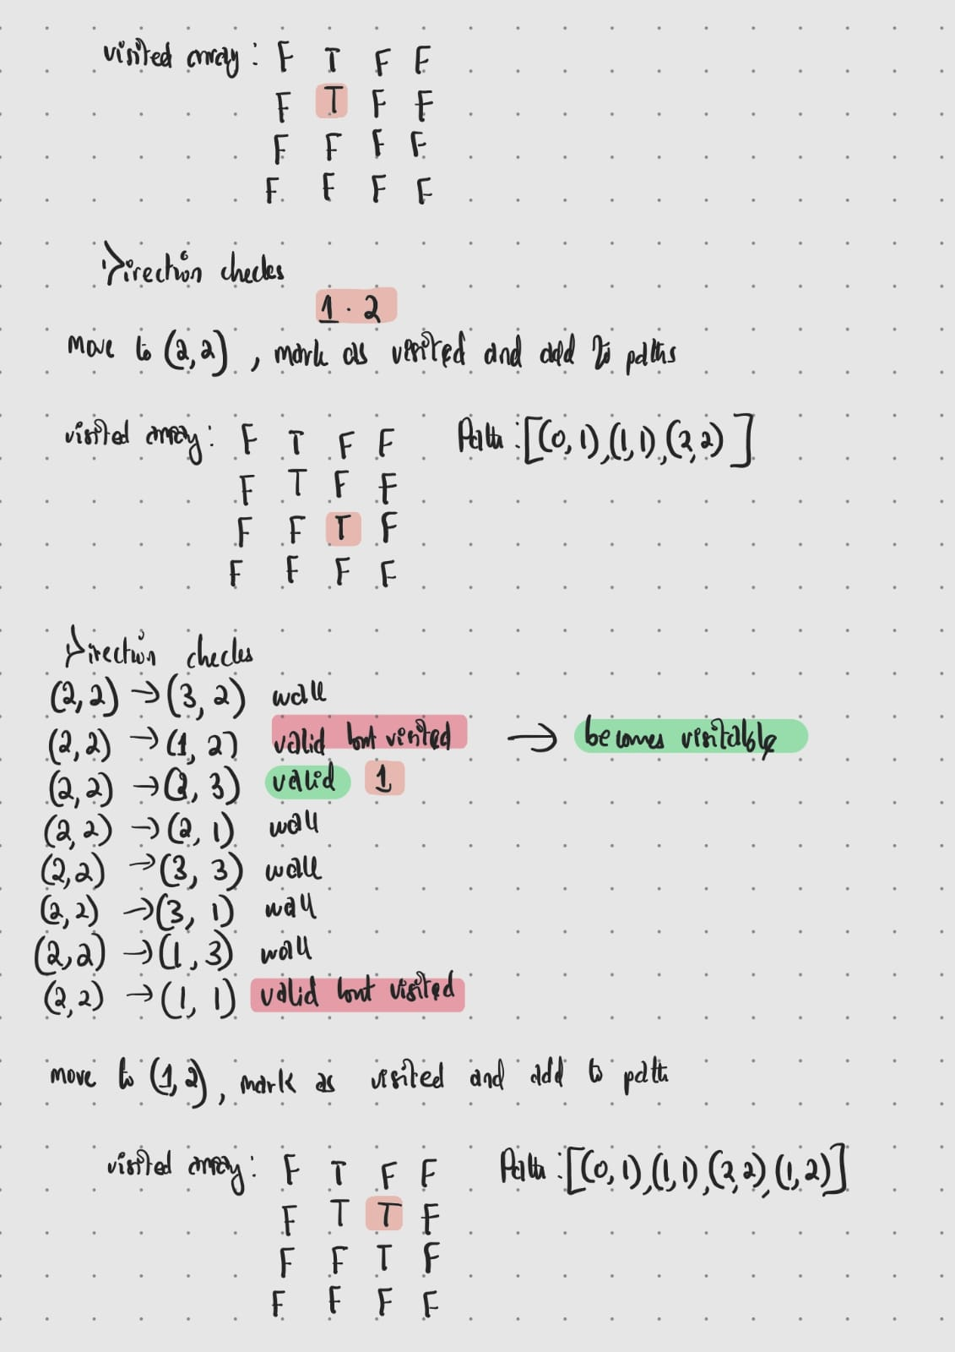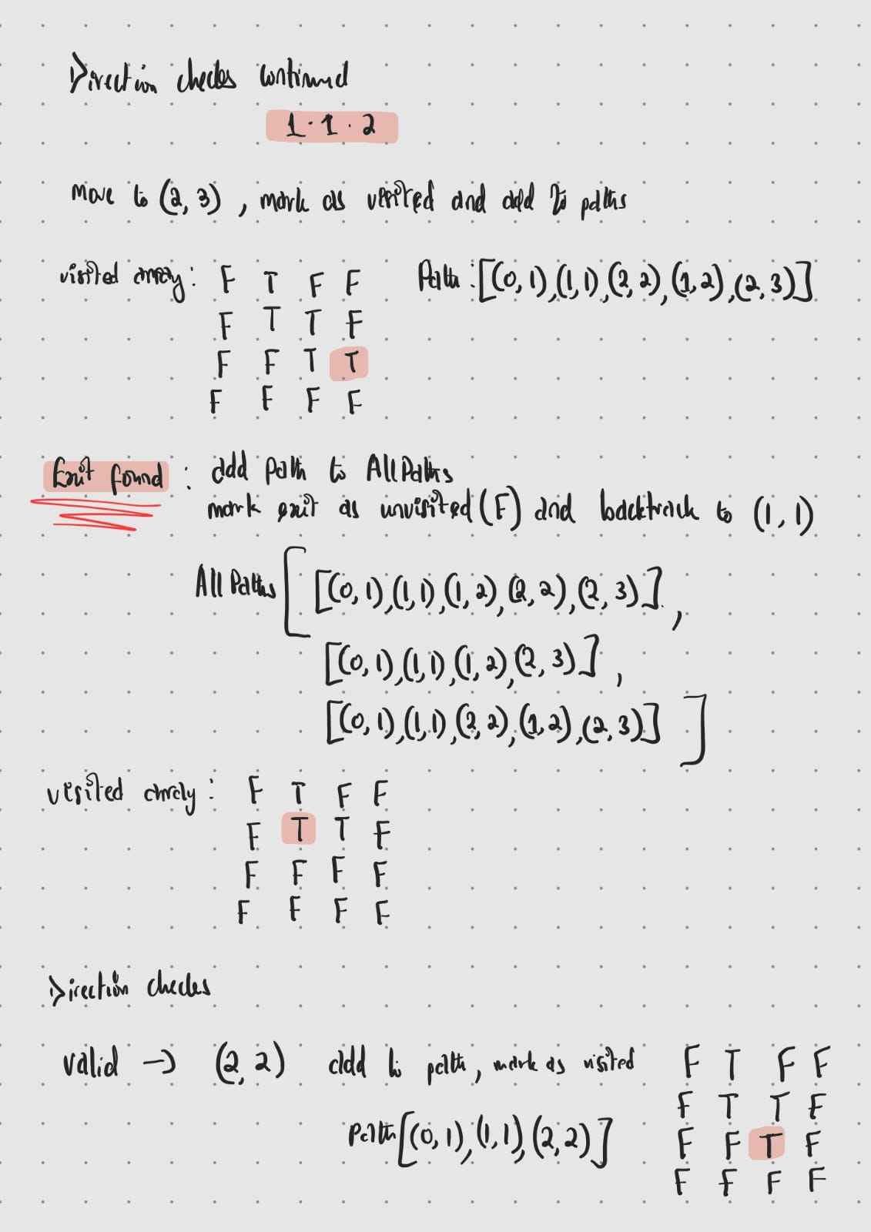

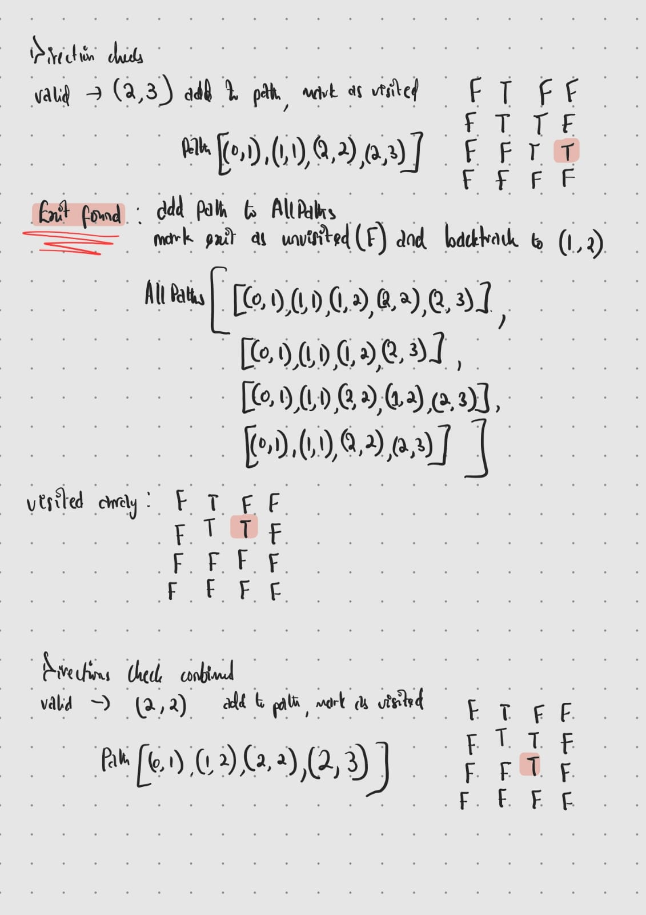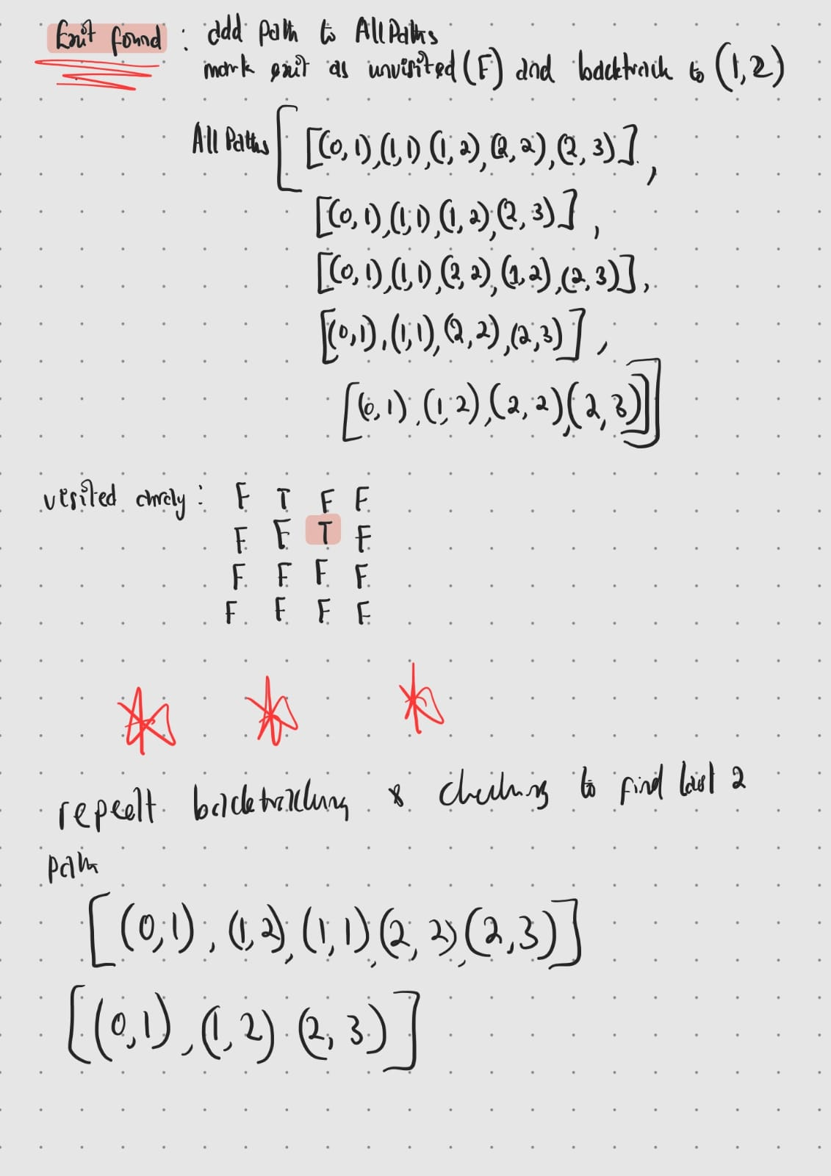

The DFS algorithm systematically explores each potential path from the entry to the exit, recursing deeper into the maze until no further moves are valid or the exit is reached.
Backtracking plays an influential role in DFS, ensuring that all possible paths ae explored without redundancy. When a path reaches a dead end or completes at the exit, the algorithm removes the last cell from the path from the cell and goes back checking the alternative unexplored routes, hereby enabling a comprehensive search of the maze.
The complexity of the DFS algorithm is O(n+m) where:
n is the number of cells in the maze (i.e. vertices)
m is the number of edges (possible moves between cells)
This is due to the depth first traversal typically resulting in a linear time complexity which is proportional to the sum of the vertices and the edges (Geek for Geeks, 2024). As discussed, the inclusion of a HashSet was unnecessary due to the DFS’s inherent ability to produce unique paths. The avoidance of additional data structures keeps the implementation simpler and more memory efficient.

Why I didn't use Stacks: The decision not to use stacks as my solving strategy involved the following considerations:
Simplicity: recursive search mirrors the natural flow of exploring paths and backtracking and so it felt more intuitive and easier to implement. Also, using recursion eliminated the need to manage a separate stack (data structure) and thus simplifying the code.
Efficiency: the boolean array I used to mark visited cells achieves the same functionality of a stack (storing data about visited cells) but does so in a constant time (O(1) access time), if I used a stack there would be a requirement for additional operations like push and pop and need for memory allocation which seems like unnecessary memory use.

2.5 Incorporation of formative feedback
Provide evidence of how you evaluated and acted on the formative feedback you received from your tutors, including the tutor’s name and the timestamp.

Date and Time | Name of the Tutor | Feedback of the tutor | How the comment is addressed
21/11/24 | Mehmet Ozcan | Use examples and diagrams to discuss the choices of data structures. | I added diagrams as examples to illustrate what each data structure looks like.
 |  | Include a space time trade-off analysis. | I discussed matrix vs linked list and stack vs visited array in terms of an analysis of the space time trade off.
 |  | Discuss why another method of solving (stacks) was not used | I enumerated on why i didn't use stacks in the report.

3. Project 3
This project involved writing two algorithms to calculate the influence score of nodes in weighted and unweighted graphs. The influence score is a metric used to assess how central a node is within a graph and is used to determine key influencers in a network.

3.1 Data Structure selection

Dictionary for graph representation and distance storage: I used a dictionary to represent the distance from a start node to other nodes during traversal of the graph and an adjacency list of the graph with keys denoted nodes and corresponding value is a list of neighbouring nodes and or weighted edges. The time complexity associated with adding nodes to the dictionary is direct access time O(1) and the traversal time is O(v+e) where v is the number of nodes and e is the number of edges. It is possible i could have used an adjacency matrix, but it has a fixed size resulting in a higher space complexity O(v^2) compared to the dictionary, it is unsuitable for sparse graphs due to large memory waste. I could also make use of an array for the distance storage, but due to requirements for mapping the node indices, it could potentially be less readable and prone to errors leading me to forgoe this.

List for neighbouring nodes: I used a list (incorporated as the value in the dictionary) to store the neighbouring nodes (of a target node) and the weights of each node. The time complexity for traversal of this list is determined by the number of neighbours for a node, resulting in a complexity of O(n) where n is the number of neighbours of node. Alternatively, I could use a set to store this data, but due to it requirement of proportionally more memory for larger datasets, a list was a more appropriate choice.

Priority queue: In the weighted graph’s algorithm I used a priority queue to effectively store the smallest distance to the next node (from the target node). Due to a method known as heap-based implementation, the time complexity for insertion and removal into the priority queue resulted in O(log n) where n is the number of nodes. A possible data structure option to use instead is a simple list but the time complexity required to find the minimum distance node is higher at O(v), making a priority queue a better choice. While implementing it in C# i stumbled on an older method known as a Sorted set, it achieved the same goal, but due to it being harder to implement as it was meant for older versions of .NET, I used the appropriate priority queue.

3.2 Developed Algorithms

Algorithm1: Influencers in Unweighted Network
The goal of this algorithm is to calculate the influence score of a node by finding the distance of the shortest path between the node and other nodes using Breadth first search.

Time Complexity of Algorithm1: Discuss about the time complexity of Algorithm1 that you have developed.

Time complexity: O(n + e) where n is the number of nodes and e is the number of edges
In breath first search, traversing all nodes and edges once has a linear complexity which is relative to the graphs size (n by e)
Space complexity: O(n)
The space required for the queue, dictionary and visited set at most will be equal to the length of the number of nodes, hence the complexity.

Pseudocode
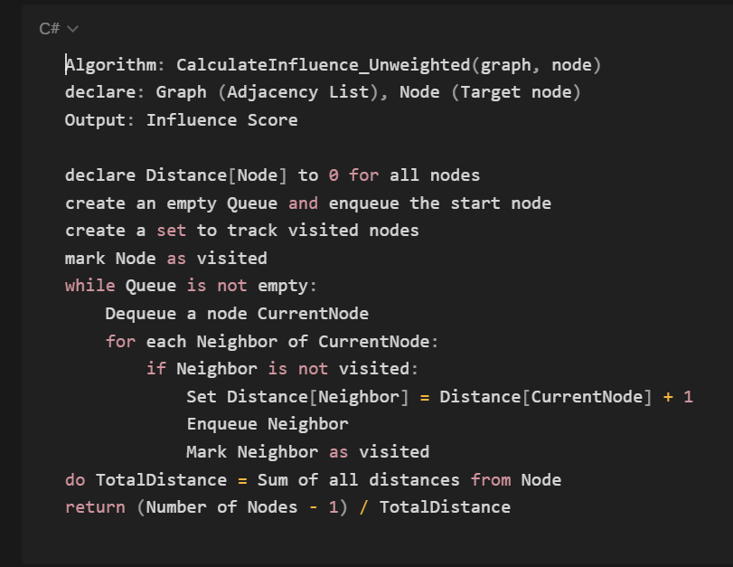

The set up of this algorithm starts with creating a dictionary initialised to a distance of zero for all nodes (from start node). I then created a queue to manage node traversal from the start node and a set to track the visited nodes in order to avoid redundantly visiting nodes.
I go through a while loop for as long as the queue is not empty, dequeue the current node, explore its neighbours and update their distance if they are not visited. The neighbour’s distance is updated using “distance[currentnode] + 1” because all edges in an unweighted graph have equal weight (of 1). This process is done until all available nodes are explored.

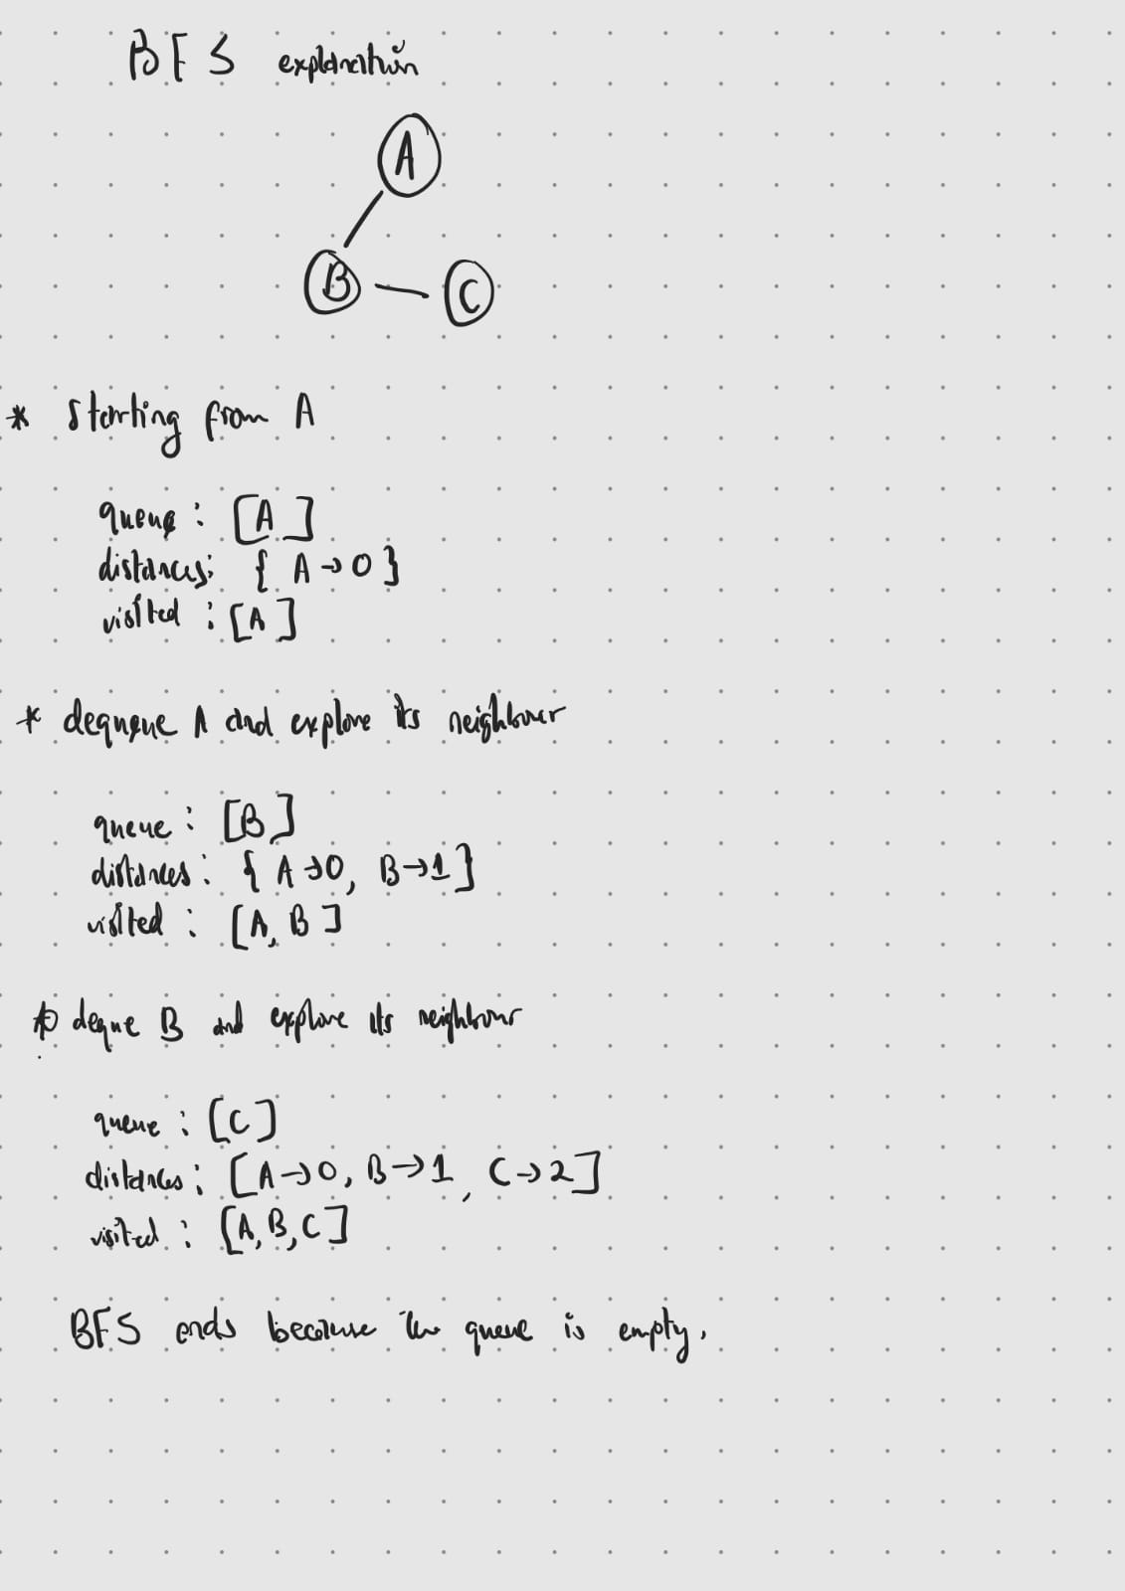
Diagrammatic explanation of the BFS logic.

3.2.2 Algorithm2: Influencers in Weighted Network
The goal of this algorithm is to calculate the influence score of a node by finding the distance of the shortest path between the node and other nodes using Dijkstra's algorithm.

Time Complexity of Algorithm2: Discuss about the time complexity of Algorithm2 that you have developed.
Where n is the number of nodes and e is the number of edges in a graph:
The time complexity for Dijkstra's algorithm is O(n^2 log n) as a result of the use of priority queues in computation. The [n^2] portion is a result of the algorithm being inefficient or the graph being dense leading to more loops while the [log n] portion is a factor determined by inherent priority queue operations. The space complexity of O(n + e) represents the largest possible space needed for the algorithm which would be the size of the graph (Geek for Geeks, 2024b).

Pseudocode
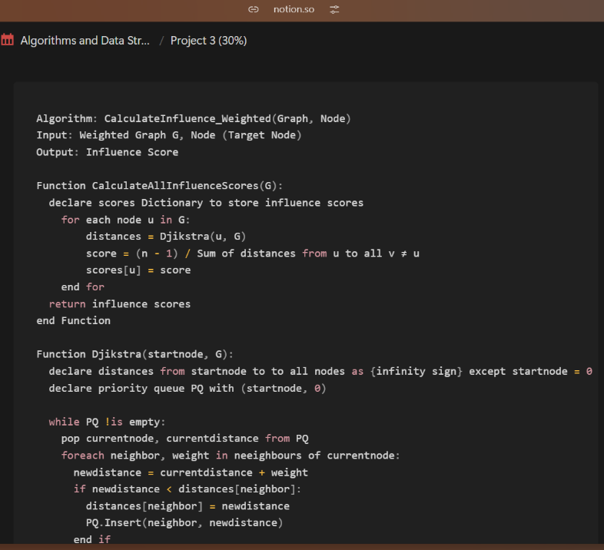
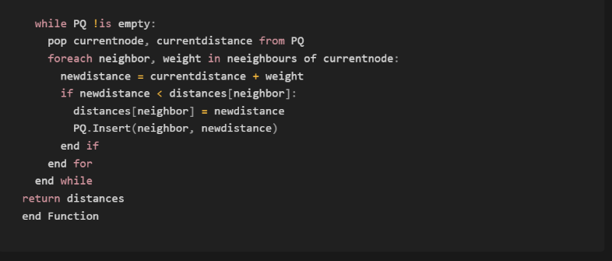

The process of this algorithm involved initializinga dictionary to store the distances from the start node to all other nodes and their initial values are set to infinity because they are perceived as unreachable except the distance to the starting node (itself) which is set to zero. A priority queue is created to select nodes with the shortest known distance. For the main portion of the code, a while loop conditioned to work whilst the priority queue is not empty follows a process of dequeuing the node at the top of the queue, checking its neighbour’s and determining their distances as “current distance + edge weight”. The dictionary (that stores distances) is updated, and the neighbour is added to the priority queue. Below is a diagram explaining how this algorithm works.

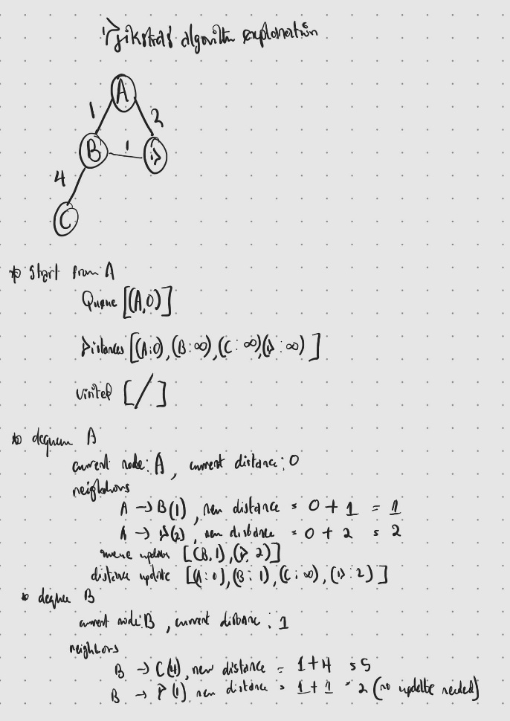

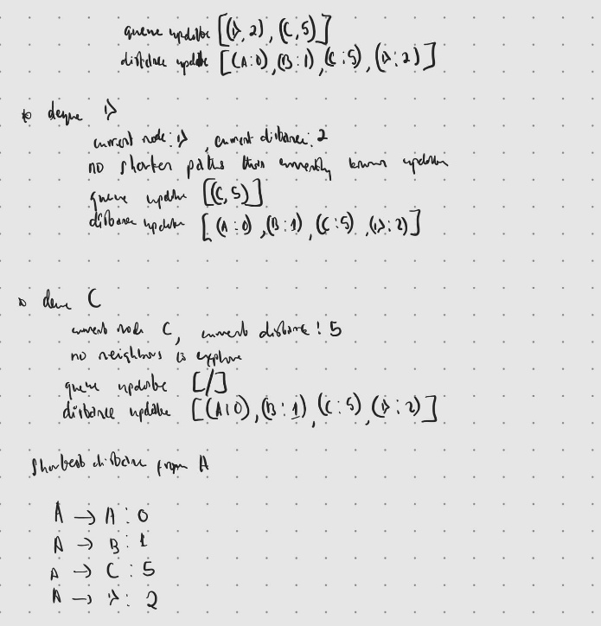

Implementation

3.3.1 Implementation details
My implementation strategy was fairly simple. I tested the algorithms using the provided diagrams in the project brief by calling functions in the main method and adding them directly to the respective graph adjacency lists like in the diagram below.
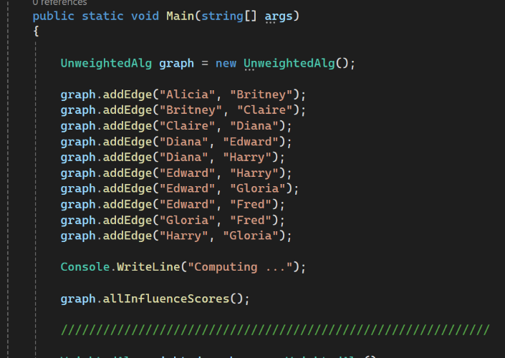

I created a method all influence scores that calculates the influence score of all nodes in the graph and returns the nodes with the highest and lowest influence score.
For the road network file, after checking in the file i determined that since only two variables where given it was an unweighted graph and created a method to read from the file and add to an adjacency list.
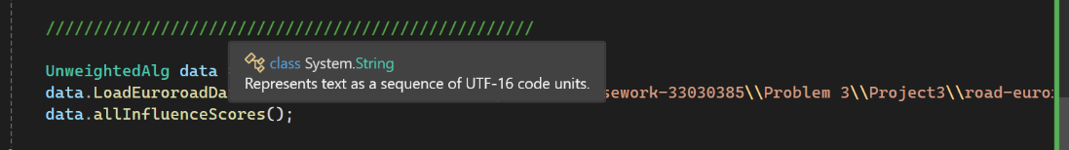
Afterwards i followed the same method to call the method: all influence scores which then determined the routes with the highest and lowest influence scores.

3.3.2 Publishing your project
https://github.com/oknabeelah/Project-3-ADS

3.3.3 Evaluation
To access the scalability of implementation, I tested the algorithm on the recommended euro road dataset from “newtworkrepository.com”. Upon execution I noticed the portion for this took a noticeably longer time to output its result and decided to time and compare the portions. The results are as follows:
Unweighted test graph
Number of nodes: 7
Execution time: 47 ms
Highest influencing node: Diana (0.583)
Lowest influencing node: Alicia (0.292)

Unweighted euro road dataset
Number of nodes: 1173
Execution time: 657 ms
Highest influencing node: 1173 (355)
Lowest influencing node: 657 (0.026)

The linear complexity of breadth first search (BFS) is the reason for the fast processing in the first search, there is a visible lag (time difference) for the second search which can be attributed to the higher number of nodes. The ratio of nodes to execution time comparison is 0.15 for the test graph to 1.79 for the euro road dataset which indicates inefficiency of the algorithm when larger data is being computed. It is possible that using an optimisation method like parallel processing (a method where multiple data processing operations are done simultaneously (Geek for Geeks, 2020)) the algorithm’s performance can be enhanced.

Reflection

3.4.1 Video
YouTube Link.

3.4.2 Feedback
Provide evidence of how you evaluated and acted on the formative feedback you received from your tutors, including the tutor’s name and the timestamp.

Date and Time | Name of the Tutor | Feedback of the tutor | How the comment is addressed

4. Project 4

4.1 Introduction to Bin Packing Problem
The bin packing problem is a classic optimisation problem that requires items (blocks, in this case) of varying sizes (heights) to be placed into a finite number of bins or containers, each of a given fixed capacity (volume, height, etc.). The crux of the problem involves packing the items in as few bins as possible while adhering to capacity constraints. Because of its dual nature as both an optimization problem and a decision problem, the bin packing problem can be classified as NP-hard and, in its decision version, NP-complete. However, since the focus of this project is on the optimization version of the problem, the discussion will centre on its NP-hard classification.
Complexity class: the optimization version of the bin packing problem is classified as NP-hard because its solution requires minimizing the number of bins used to pack a finite number of blocks, where each bin has a fixed capacity. Finding the optimal solution involves exploring an exponentially growing number of possible arrangements as the problem size increases. This classification highlights the computational difficulty of finding a solution that not only satisfies the constraints but also minimizes the objective (the number of bins used). The NP-hard nature of this problem arises because no known polynomial-time algorithm can guarantee an optimal solution for all instances. As the problem size increases (more blocks or larger capacities), the number of possible arrangements grows exponentially, making it computationally infeasible to check every possible solution. (Lewis R., 2009).
Dimensionality of problem: In this project, the problem is treated as a one-dimensional optimization challenge, where items are represented by their heights and bins have a fixed height capacity of 130 cm. The width is irrelevant because it is assumed that the blacks have the same width as the bins so can only be stacked on top of each other not packed side by side. This focus simplifies the problem compared to multi-dimensional variants (e.g., 2D or 3D packing) but retains its computational complexity and relevance to real-world scenarios.

4.2 Random Mutation Hill Climbing

Given its NP-hard nature, exact solutions to the optimization version of the bin packing problem are impractical for larger instances. Instead, heuristic approaches such as Random Mutation Hill Climbing (RMHC) are commonly used. These methods provide near-optimal solutions within reasonable time constraints by exploring the solution space strategically rather than exhaustively.

In the context of this project, RMHC iteratively refines solutions by applying small changes also known as mutations to improve the solution (Geek for Geeks, 2017). While this does not guarantee an optimal solution, it is effective in reducing the number of bins used for large datasets.

Approximation algorithms and heuristic methods like RMHC are essential for real-world applications of the bin packing problem. These include logistics (Romero et al., 2023), server load balancing, and resource allocation (Study Smarter, 2025). By focusing on minimizing bin usage while adhering to constraints, these approaches address the practical challenges of managing limited resources effectively.

In this project, the RMHC algorithm is employed not only to minimize the number of bins but also to balance bin utilization and reduce wasted space, leveraging fitness functions as a guide to the search for an efficient solution.

4.3 Algorithm Design

4.3.1 Solution Representation
I am presenting the solution as a list of integers as long as the data set providing the list of block heights where each integer represents the bin number, and its index matches a specific block in the block list, denoting that the block is placed in that bin. Because of the use of a randomizer in the solution generation the bin numbers do not begin symmetrically (0, 1, 2, ...) and so I have included in the code a function that counts the unique numbers in the list and returns an integer which represents the number of bins used in the solution.

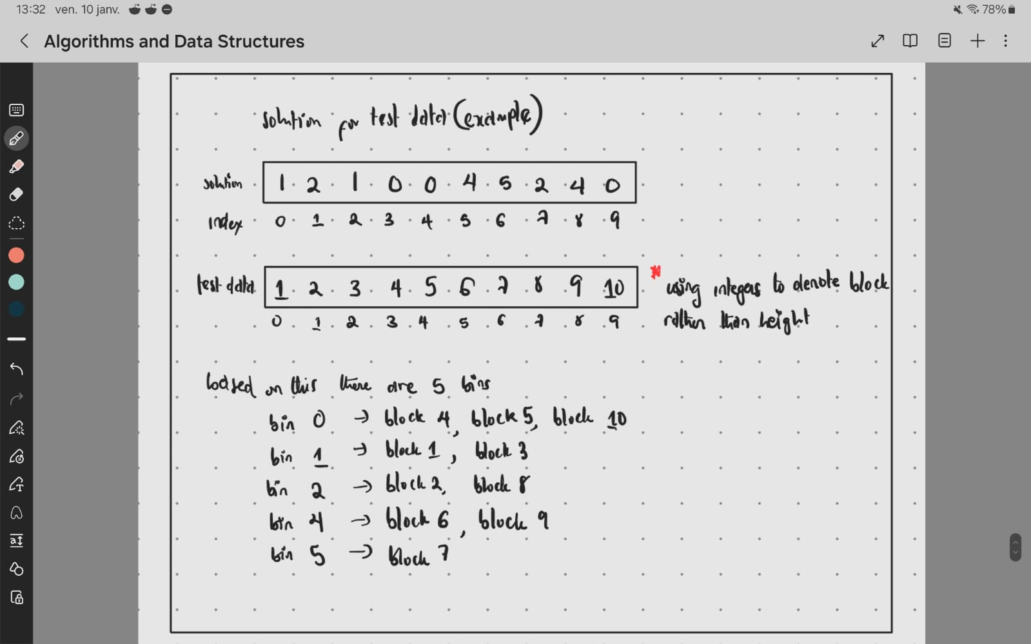

4.3.2 Fitness Function Analysis

I explored several fitness functions for this problem and resulted in tweaking my final solution to better work with the problem and the small change strategy. There were three objectives the fitness function needed to cover:
Minimising bin counts: It was important that the bins used as few bins as possible without overflowing. I wanted to reach a solution that used between 30% and at most 50% of the bins provided. This fitness function was plainly represented by the number of non-empty bins, so the smaller the better. However, my code simply resulted in compounding to 1 bin because it produced the least fitness which was in no way efficient.
Balancing Bin usage: Another important factor was the balance between bins, even more important than the amount of bins used. I wanted to focus on spreading the blocks between the bins as evenly as possible. For this i represented the fitness in two ways.
- Using the variance formula
- As the difference between maximum bin height and minimum bin height
Between these two I ended up focusing on the latter as the variance formula needed quite a bit of computation and I had to keep in mind that constantly accessing the dataset was not computationally efficient. As a result, I chose the bin height (max-min) as a simplified alternative. This was represented as an integer where the smaller the better, indicating the block dispersal between the bins is not too high.
Minimising wasted space: Finally, and possibly the most important, I considered the use of space in each bin and focused on reducing wasted space. This sounds oddly similar to the above balancing bin usage fitness but it’s quite different as this manages the unused space in each bin and making sure it's as small as possible. It is represented as an integer sum of the bin height subtracted from the bin capacity for all bins.
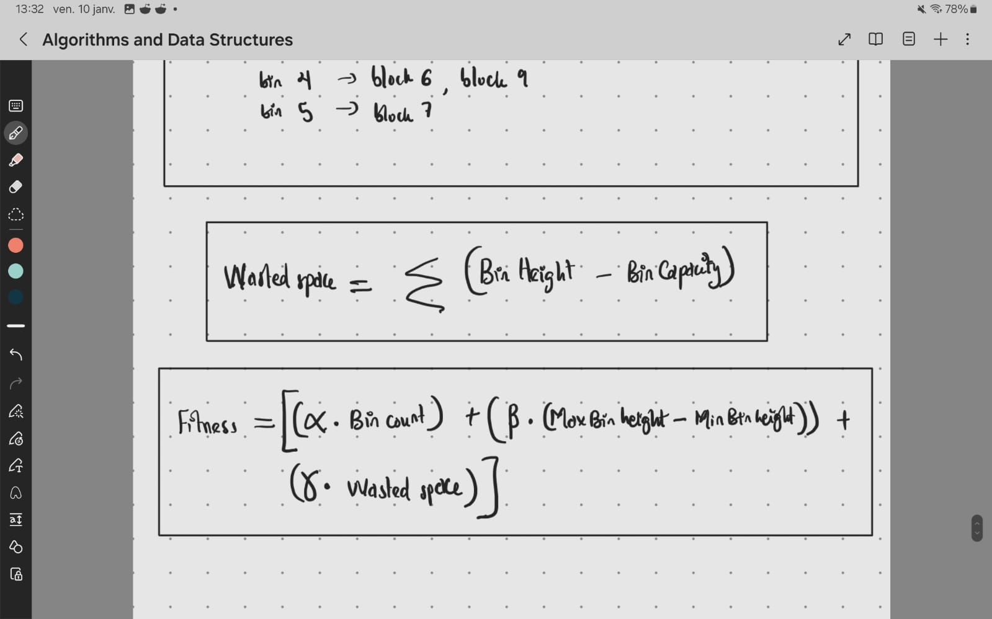
In considering all the fitness functions above I decided to combine them together to one formula, incorporating weights to rank the importance of each factor.
Alpha (ɑ) - encouraged fewer bins
Beta (ß) - encouraged evenly dispersed bins
Gamma (γ) - encouraged more tightly packed bins

The symbols were used to represent weights for each factor in the formula and especially in the case of ß, was kind of test fitted to the formula.
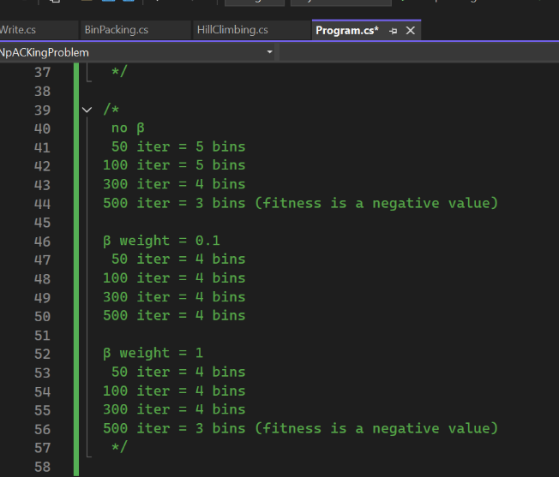

I determined ß to be worth a 0.1 weight and both ɑ and γ be worths a weight of 10. A detailed use of the fitness function for the test data is outlined in the diagram below.

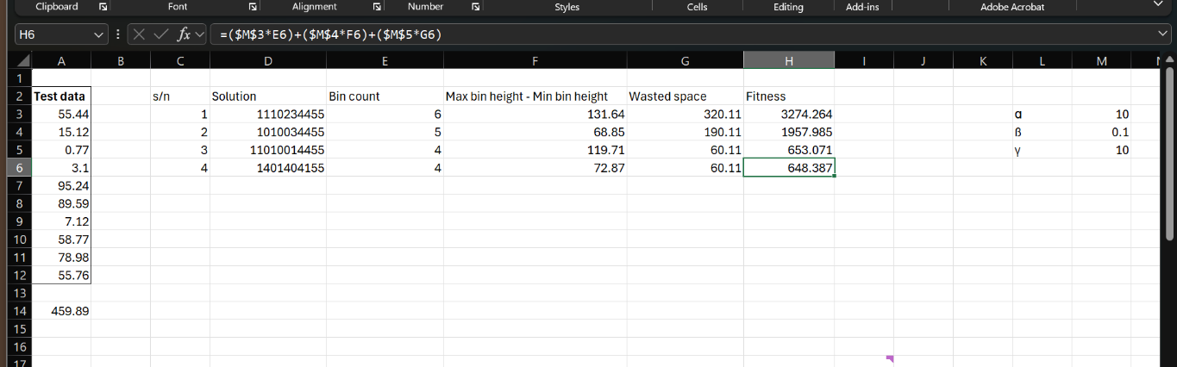

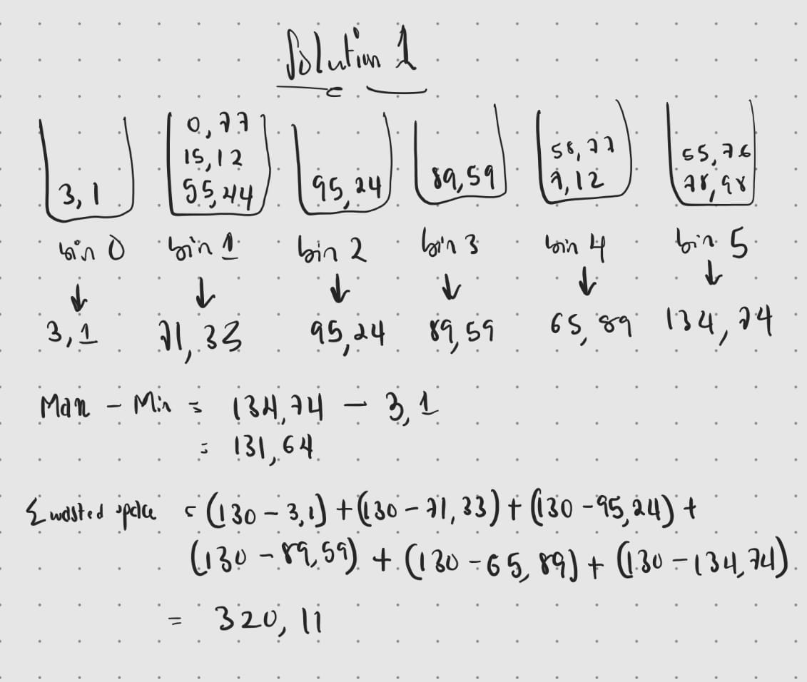

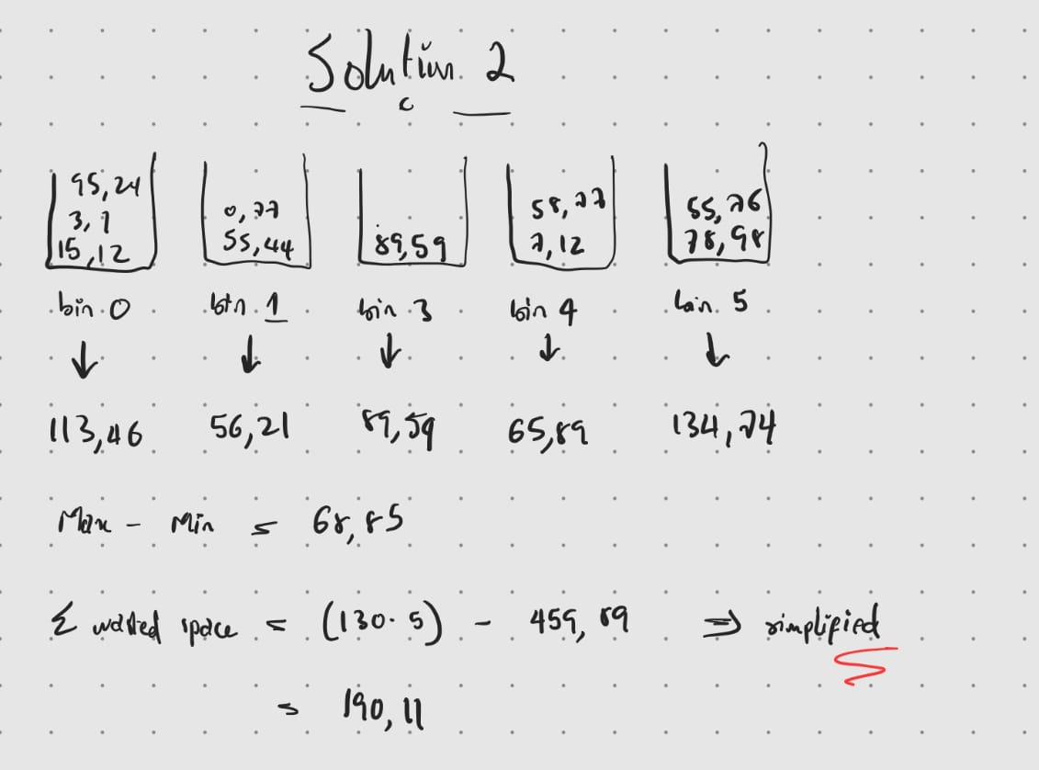

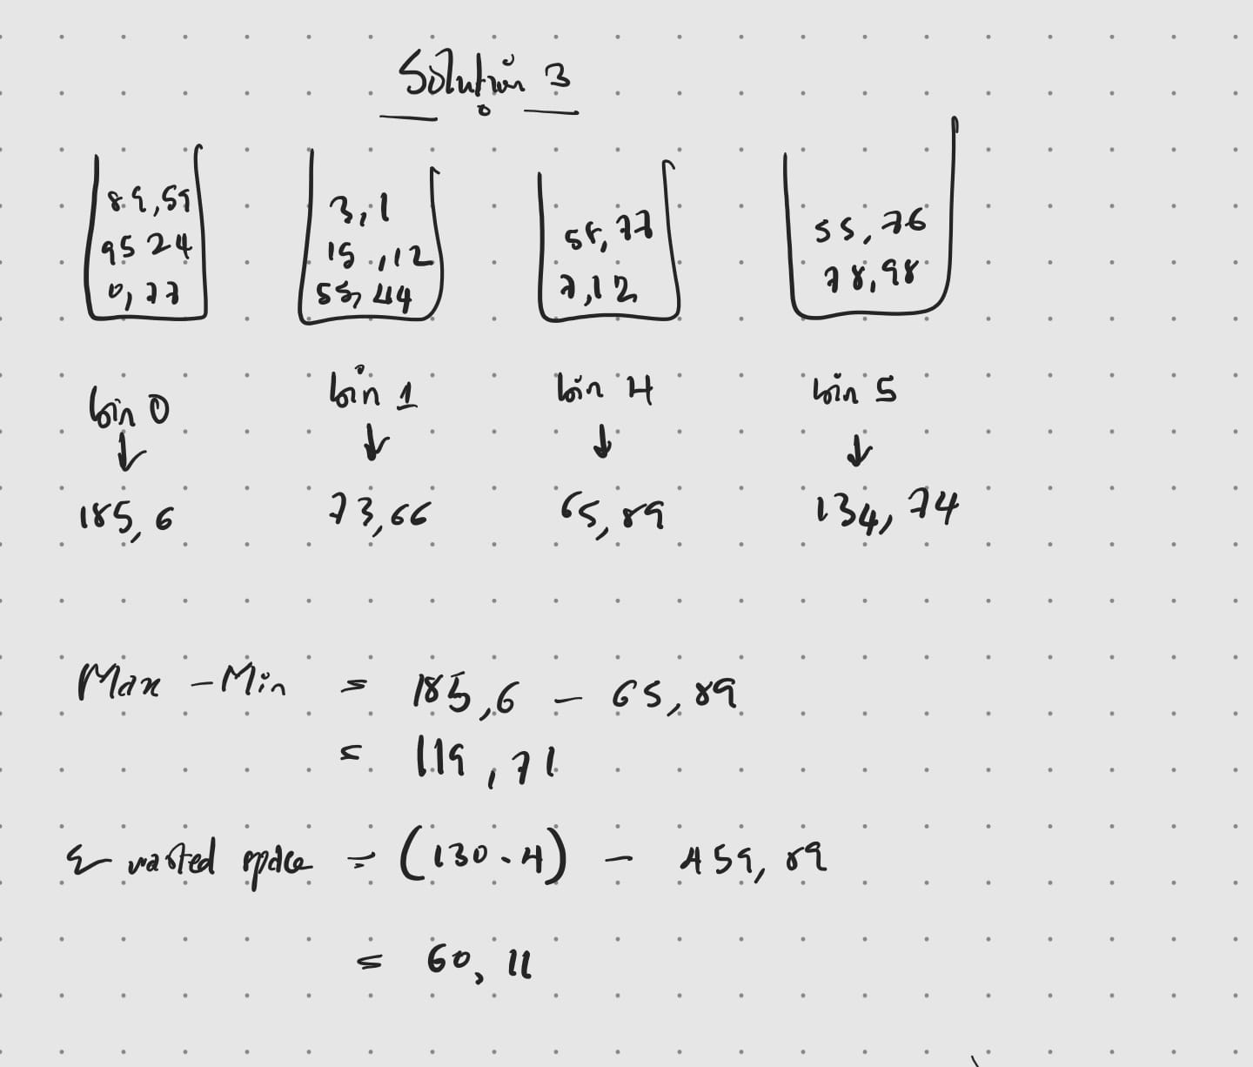

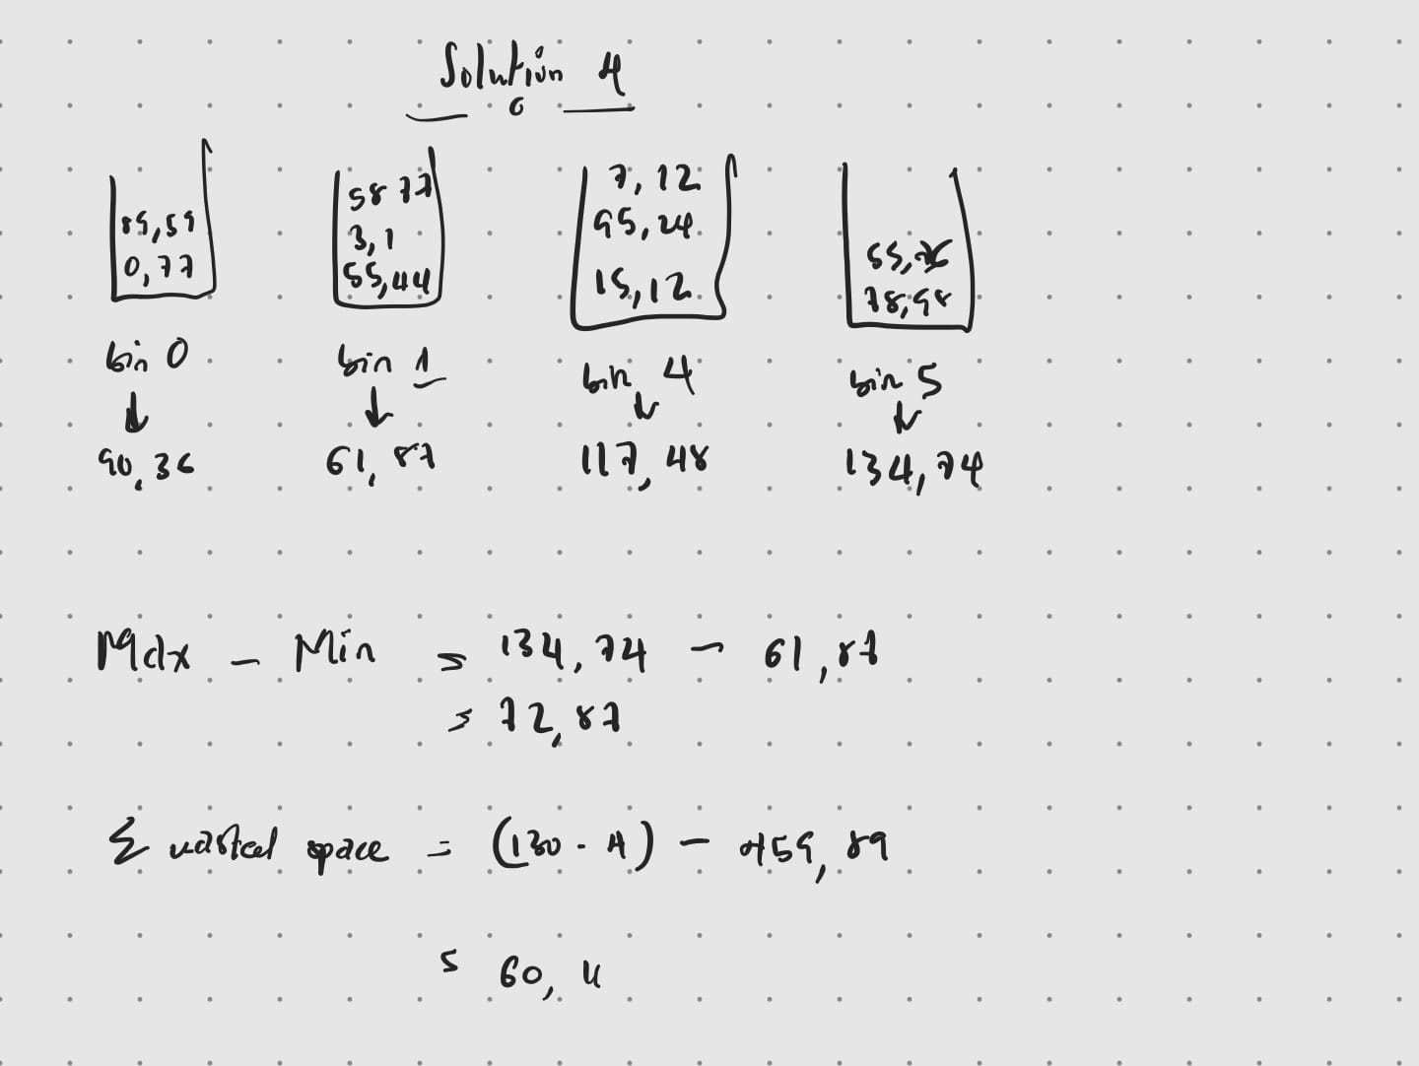

4.3.2 Small Change Strategy
Initially my small change strategy involved redistributing blocks between bins in a strategic and highly specialised way. However, the solution because highly computational and even inefficient as it stagnated in the middle of the iterations as there was no other way to change the solution and would most likely have placed all the blocks in one bin.
After much thought I decided to heavily simplify it to work cohesively with the fitness function, so each small change is meaningfully checked when the fitness function is calculated. My updated method randomly selects any block from the solution list and reassigns it to a randomly chosen new bin that is not the same as its current bin.


It randomly selects an index for a block in the solutions list, retrieves the current bin it is assigned to and randomly reassigns it to another bin. I have seen that this method works best because of its simplicity, focusing on one task (reassigning a block) without complex inclusions like looking to the dataset. It is also efficient and scalable; it avoids unnecessary iterations over the bins and executes in O(1) timing making it perfect if the dataset is increased.
This is very different from my previous small change strategy whereby i devised a highly specialised system to achieve a lot within a single small change iteration it became a setback in my code.
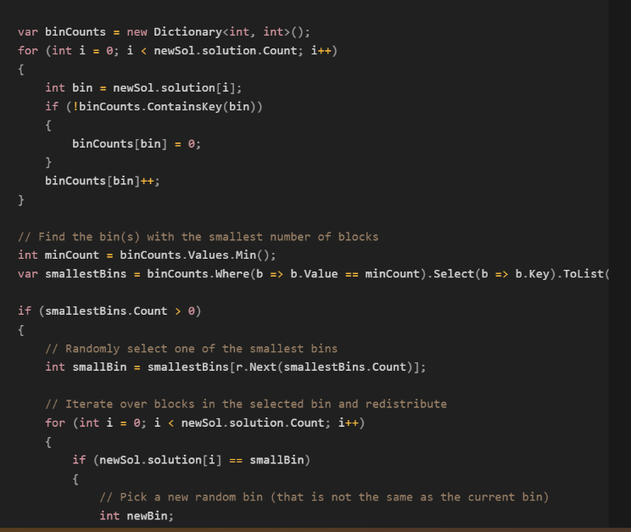
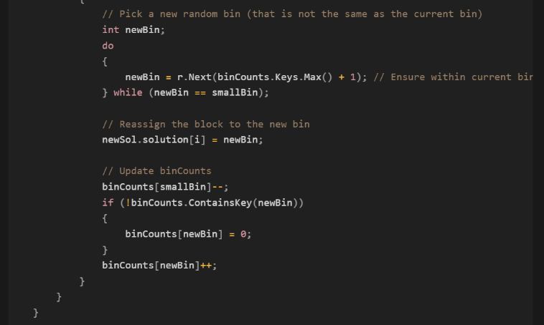

This method would iterate over the solution, counting the bins with the least number of blocks and reassigning them to another bin. Although this method seems like the dream and a key to a great solution, these steps were highly specialised for a small change method, resulting in a higher complexity i.e O(n) due to bin analysis, and a slower code execution. Another sure reason for choosing the simpler method is through testing my code it was apparent that it was a better method as my results were larger with the specialised method and before fitting other sections of the code (fitness function) it often stagnated mid iteration with the resulting solution being only to use 1 bin.

4.3.4 Data Structure
Solution representation
integer list (List<int>): this was used to represent the bin assignment for each block with each integer corresponding to a bin index.
It has a time complexity of O(1) due to direct access and I've chosen it due to its dynamic representation of solutions and its well-found adaptability to scaling.

Dataset storage
Double list (List<double>): this was used to store the height of the blocks provided from a csv file and read into the code using a specially devised method (ReadData).

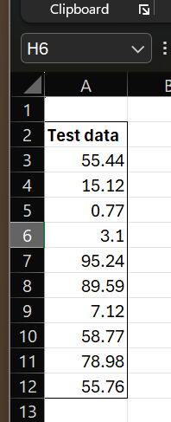

Similarly, this has a complexity of O(1) due to direct height retrieval. The data structure’s ability to resize dynamically and read datasets of arbitrary length without any fuss with input processing made it a top choice.

Main program
Within the main program, I made use of a few data structures which included:
Dictionary (Dictionary<int, double>): I used this to maintain the total height of the blocks in the bin during evaluation of the solution. The key represents the bin number, and the value represents the cumulative height of the bin. As such it has a complexity of O(1) for lookup, insertion or updated using a method known as hash-based indexing.

2D Array (double [,]): this was used to store the results of the iterations of the code in an excel file. It was initialised with three rows to include the iteration number, the current fitness value and new fitness value after small change has been executed. Its fixed size and index structure allows data to be stored efficiently, which explains a time complexity of O(1) due to direct access of elements.

List of lists (List<List<int>>): this was used to store the solutions of each iteration of the code for further study in a file. This also has a complexity of O(1) in terms of both adding an accessing solution.

Some overall reasons as to why I mostly prioritised using lists in the code include:
Dynamic Size: Lists can dynamically resize, making them suitable for scenarios where the solution representation might change. Arrays have a fixed size, requiring manual resizing. I used an array to store the results because the initial value of the number of columns was fixed.
Built-in Operations: Lists in C# come with built-in functions for insertion, deletion, and searching which made it easier for me to implement.
Memory Efficiency: Although arrays may use slightly less memory, lists offer more flexibility without significant overhead.

4.3.5 Algorithm Pseudocode

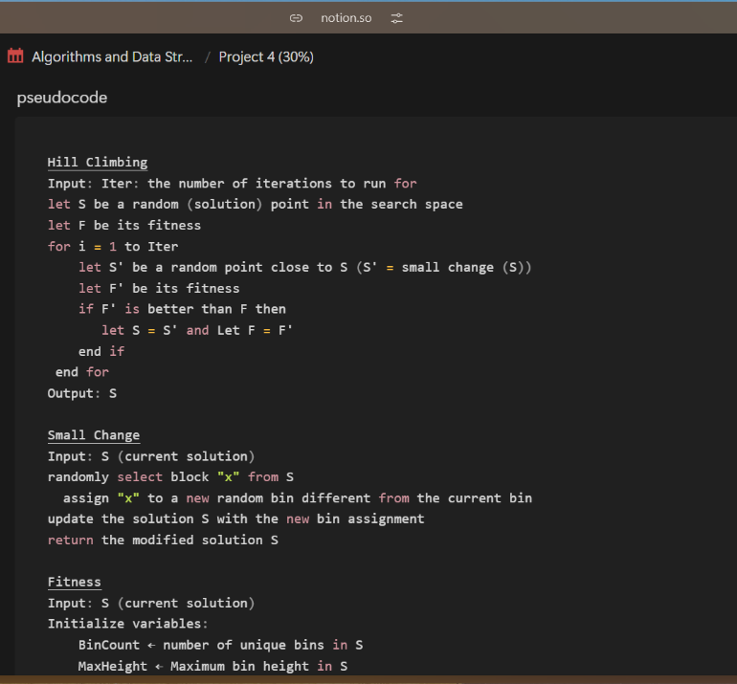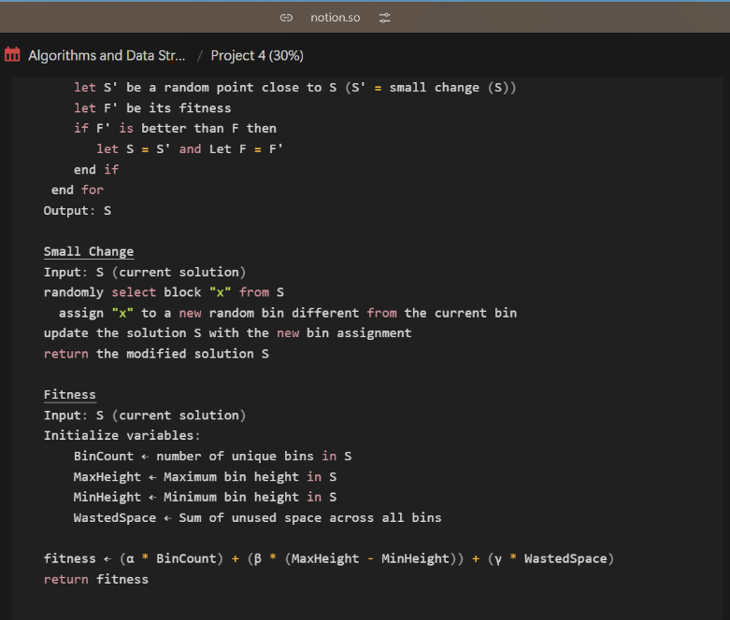

4.3.6 Experiment Strategy

To evaluate the effectiveness of the algorithm i implemented simple repeated execution of the program. The algorithm was tested over varying iteration counts in order to assess performance improvement (display a progressive efficiency of algorithm through lessening bin counts) with values ranging from 50 to 5000 iterations. I also incorporated repeated runs of each iteration count to cover variability of results due to randomization in small change.
I wanted to check that even though the small change was random, it still maintained some region of values. To do this I run each iteration value 10 times and rather than only averaging the result I displayed them all on a scatter plot for a visual representation of bin decline and because I like the aesthetics, i then provided a cleaner version of just the averages. Scatter plots are very effective in illustrating variability whilst also highlighting trends towards convergence and stabilisation

4.4 Results

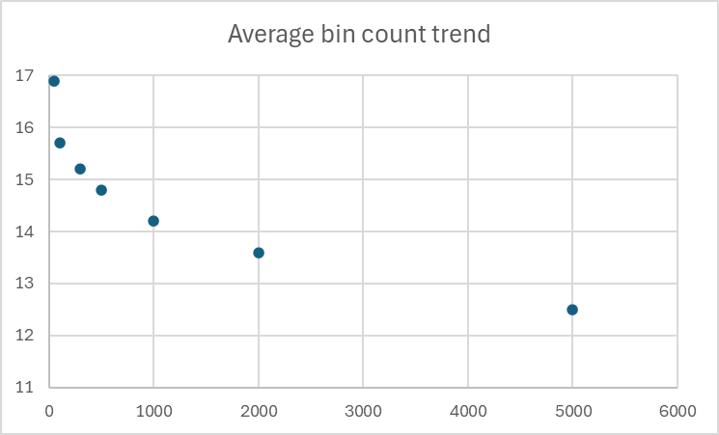

Observations
The bin count trend steadily decreased as the number of iterations increased. Initially at 50 iterations the average bin count was averaged at 17 bins, but towards 5000 iterations the bin count dropped to 13 bins. The higher iteration count allows the algorithms to explore more solutions and improve packing efficiency. Similarly, the fitness value followed a similar decreasing trend starting at an average of 9000 at 50 iterations and decreasing to 3000 at 5000 iterations.
Between 1000 and 5000 iterations, the rate of improvement slows down, which might indicate a convergence towards a near optimal solution. A stabilised result implies there are diminishing returns with increasing iterations beyond a certain point.
Finally, it is worth noting that at smaller iterations, the bin count fluctuated more widely, which would point to fewer iterations being insufficient for the algorithms to converge on consistent solutions.

4.5 Testing

Unit testing
Fitness function testing: the fitness function was tested by providing predefined solutions and calculating the expected fitness value manually. The results from the code where then compared to these pre-resolved values to check correctness.

System testing
I routinely checked the files after running a solution and compared it side by side to the console output, checking to make sure all data was store properly.

4.6 Software and its Presentation, including testing (and video link)
YouTube link.

4.7 Incorporation of formative feedback

Provide evidence of how you evaluated and acted on the formative feedback you received from your tutors, including the tutor’s name and the timestamp.

Date and Time | Name of the Tutor | Feedback of the tutor | How the comment is addressed
21/11/24 | Zairul Jilani | Incorporate analysis and diagram usage through work | Detailed analysis was added, and hand drawn illustrations were used to further explanation
 |  | Overflow and underflow management | Logic was incorporated into the fitness function to punish overflow and underflow as a management strategy
 |  | Equation verification | The fitness function was validated through extensive testing and analysis to demonstrate its suitability for the algorithm

5.0 Bibliography

Cornelius, B. J., & Kirby, G. H. (1975). Depth of recursion and the Ackermann function. BIT, 15(2), 144–150. https://doi.org/10.1007/bf01932687
Geek for Geeks. (2017, December 12). Introduction to Hill Climbing | Artificial Intelligence. GeeksforGeeks. https://www.geeksforgeeks.org/introduction-hill-climbing-artificial-intelligence/
Geek for Geeks. (2020, April 19). What is Parallel Processing ? GeeksforGeeks. https://www.geeksforgeeks.org/what-is-parallel-processing/
Geek for Geeks. (2023, September 19). NP-Hard Class. GeeksforGeeks. https://www.geeksforgeeks.org/np-hard-class/
Geek for Geeks. (2024a, February 8). Time and space complexity of depth first search (DFS). GeeksforGeeks. https://www.geeksforgeeks.org/time-and-space-complexity-of-depth-first-search-dfs/
Geek for Geeks. (2024b, February 9). Time and Space Complexity of Dijkstra’s Algorithm. GeeksforGeeks. https://www.geeksforgeeks.org/time-and-space-complexity-of-dijkstras-algorithm/
Gray, P. (2011). Psychology. Worth Publishers.
@inproceedings {nr, title= {The Network Data Repository with Interactive Graph Analytics and Visualization}, author={Ryan A. Rossi and Nesreen K. Ahmed}, book title={AAAI}, url={https://networkrepository. com}, year={2015}}
Kernighan, B. W., & Ritchie, D. M. (2017). C Programming Language.
Lewis, R. (2009). A general-purpose hill-climbing method for order independent minimum grouping problems: A case study in graph colouring and bin packing. Computers & Operations Research, 36(7), 2295–2310. https://doi.org/10.1016/j.cor.2008.09.004
Romero, S. V., Osaba, E., Villar-Rodriguez, E., & Asla, A. (2023). Solving Logistic-Oriented Bin Packing Problems Through a Hybrid Quantum-Classical Approach. ArXiv (Cornell University), 2308.02787(2308.02787). https://doi.org/10.48550/arxiv.2308.02787
Study Smarter. (2025, January 7). Bin-Packing Algorithms: Examples, Types & Applications. Study Smarter UK. https://www.studysmarter.co.uk/explanations/math/decision-maths/bin-packing-algorithms/

